# CHAPTER 6

## DEVELOPMENT OF LATERAL SURFACE6 OF SOLIDS

**Problem** 1 A triangular prism with one of its rectangular faces parallel to VP and nearer to it is cut as shown in Fig. Dfaw the development of the retained portions of the prism which are shown in dark lines.

* **Solution**

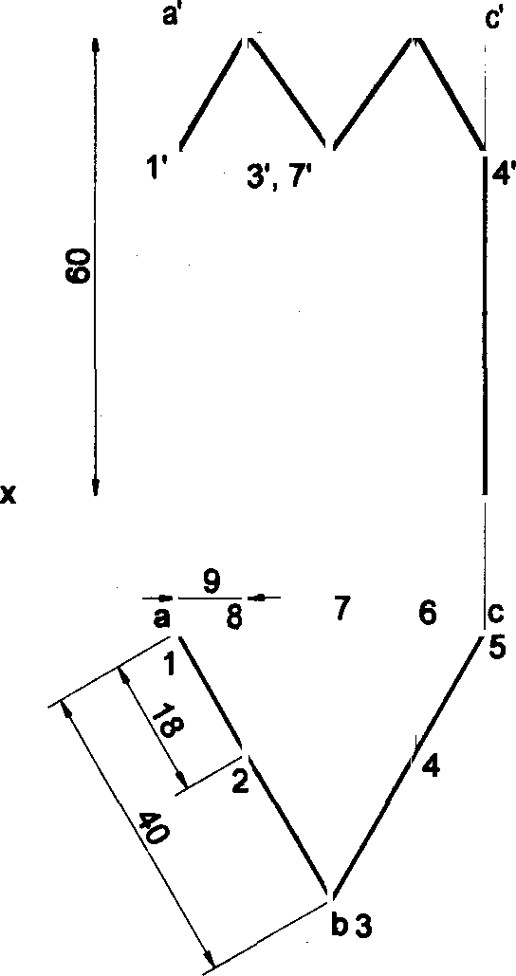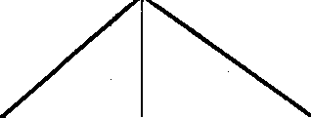

11 11

2 6'

b'

s 8'

A

2

B

4

C *8*

®

A

1

5

1

DEVEL PMENT

VP HP

1

9

40

120



.

I” Problem 2 A square prism of base side 30 mm and axis length 60 mm is resting on HP on its baae wlth all the vertical faces being equally inclined to VP. It is cut by an inclined plane 60° to HP and perp6ndlcular to VP and is passing through a point on the sxis at a distance 50 mm from the base. Draw the development of the lower portion of the prlsm.

8olutlon

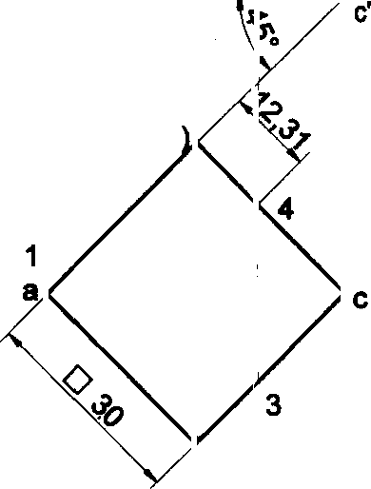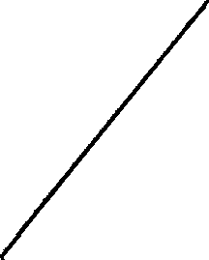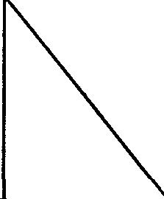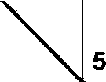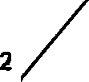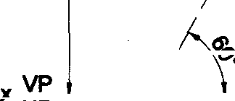

a' b' d' 3',4'

23

B |3 C 4 D

1



DEVEL PMENT

30

d,(5

120

b,(2)

125

# “

#### Problem 3 A square prism of base side 40mm and axis length 65mm is resting on HP on its base with all the vertical

faces being equally 1Mined to VP. It is cut by an inclined plgne 60° to HP and perpendicular to VP and is passing . through a point on the axis at a distanoe 15mm from the topface. Draw the development of the lower portion of the prism.

Solution

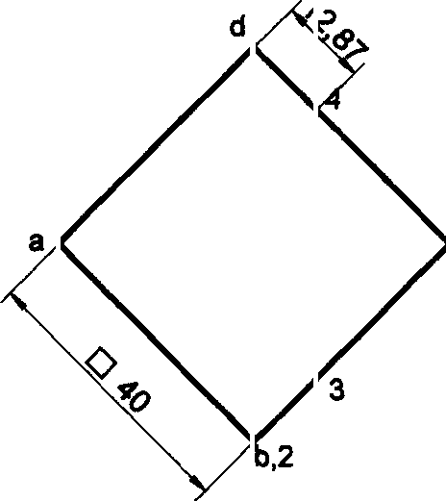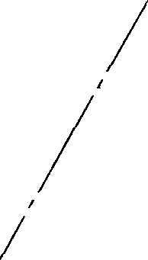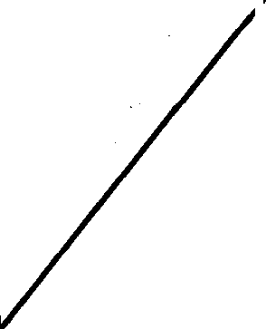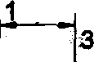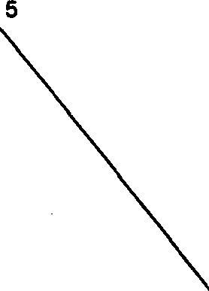

2.87

3',4'

VP 1'

HP a'

b',d'

c’ A

B

D

1

A

160

40

PMENT

DEVEL€

1

}

2(5j/

65

Problem 4 A square prism of 30mm side of the base and height 50mm is resting with its base on HP such that one of its vertical faces is irz lned at 40° to VP. It is cut as shown in the following front view figure. Draw the development of the lateral surface of the prism.

# Solution

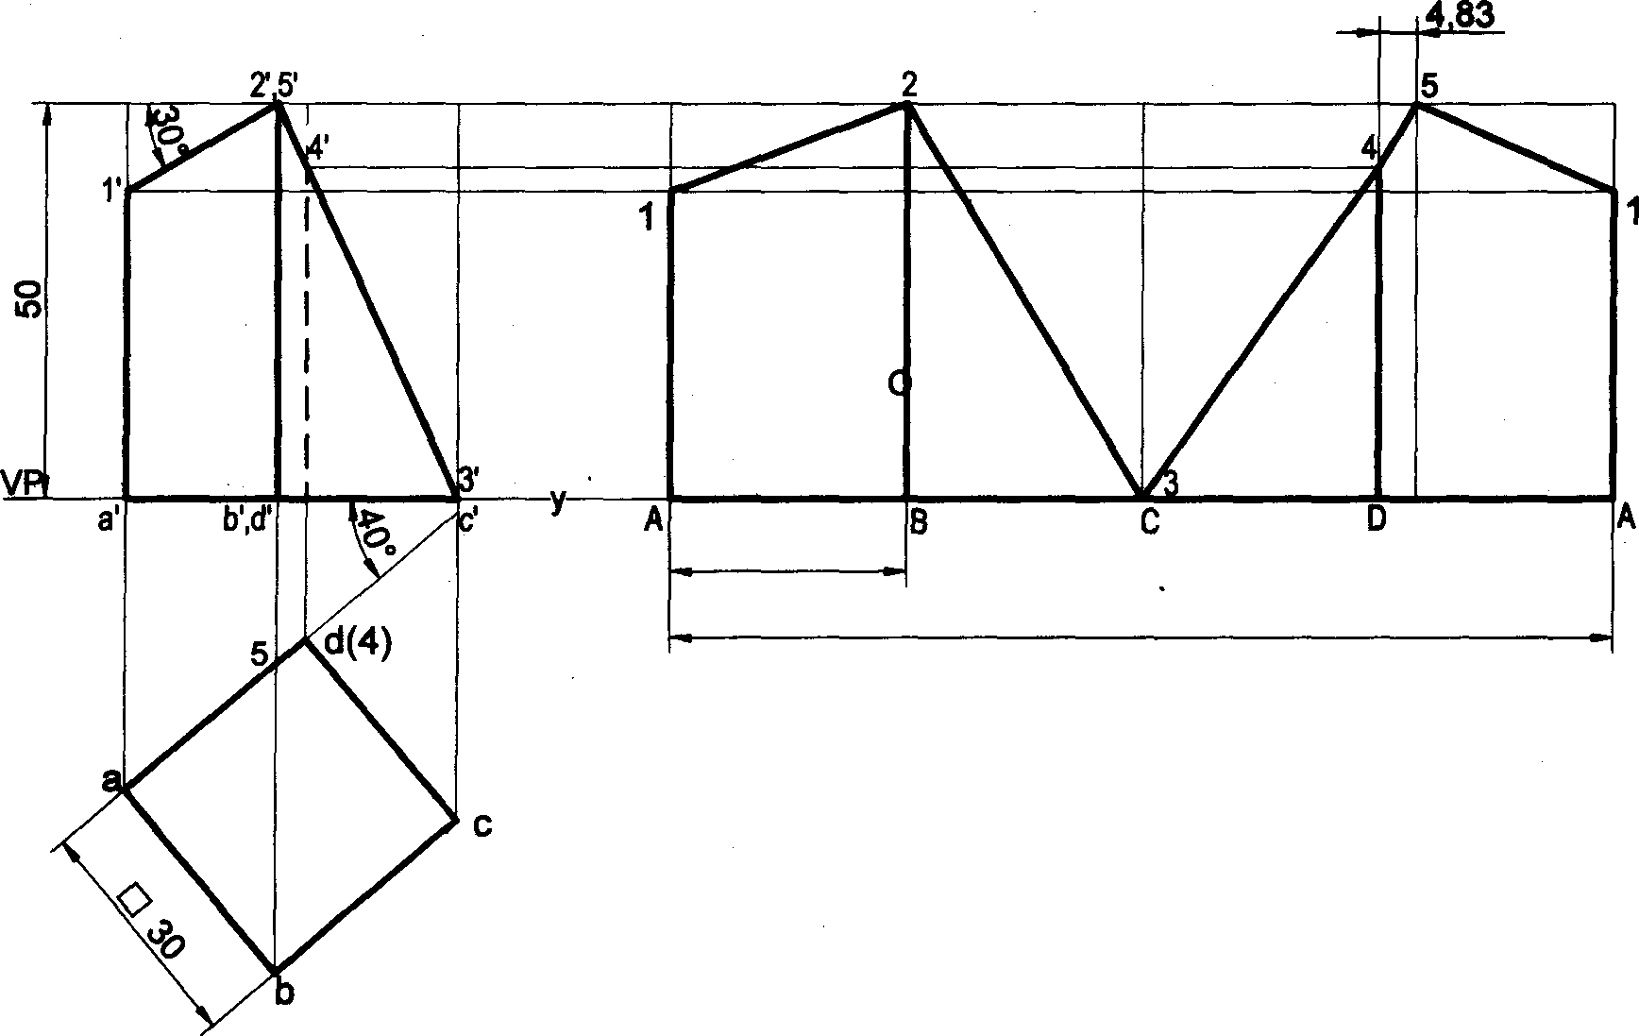

DEVEL PMENT

HP

30

120

*

126

Probfbm 5 A cube of side 40mm is resting on HP with its base on HP such that one of its vertical faces isinclined at 30° to the VP. It is cut by a section plane perpendicular to VP, inclined to HP at an angle W and passes through the midpoint of the axis. Draw the development of the lower lateral surface of the cube.

Solution

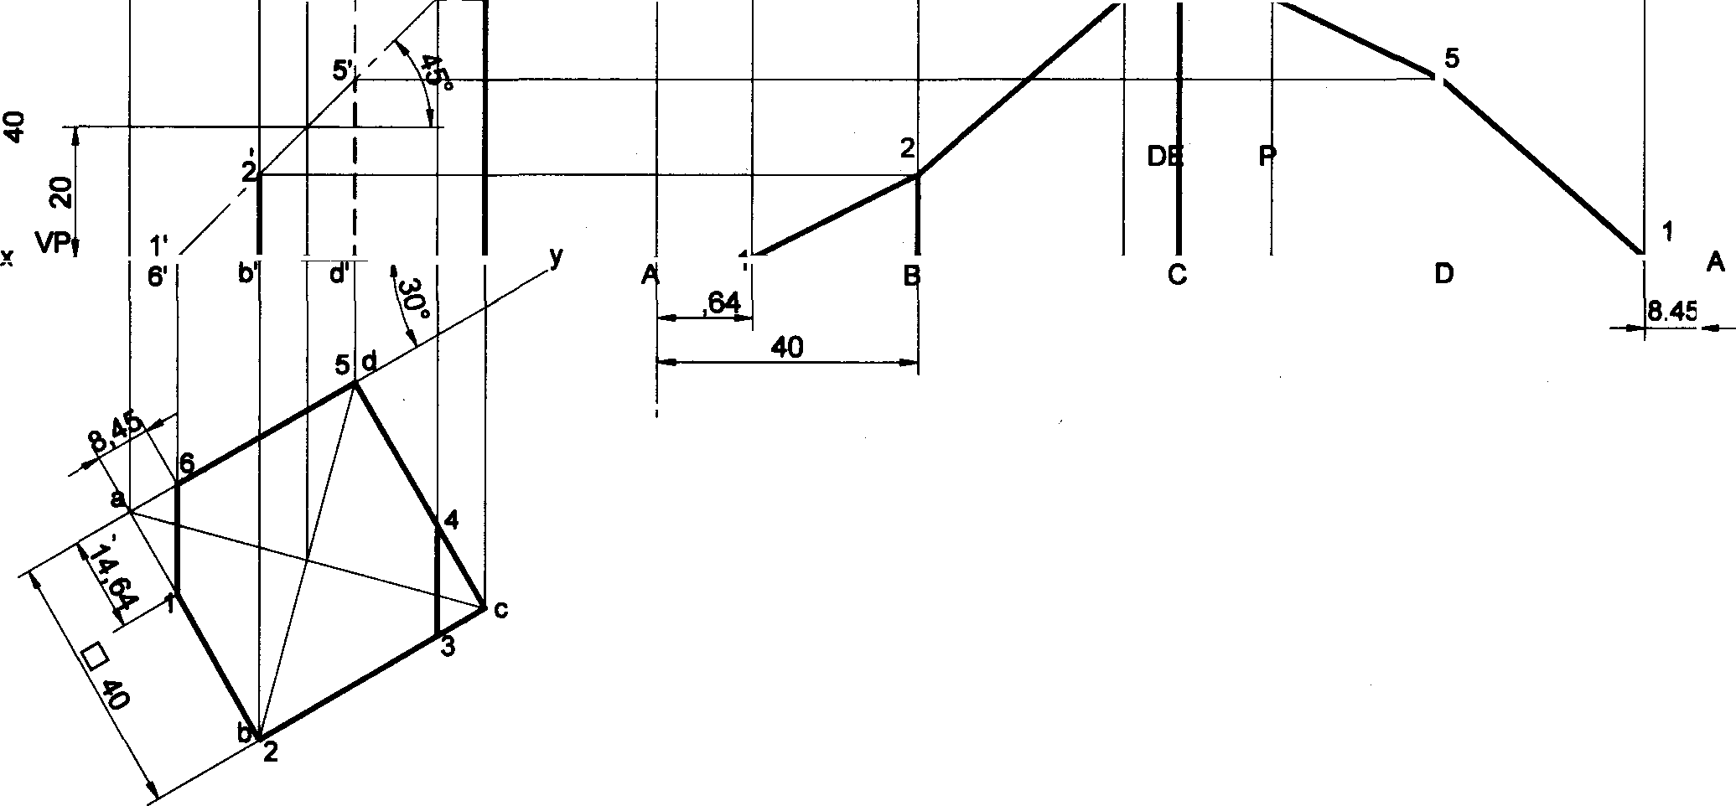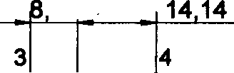

14

47

3',(4') c'

|  |  |  |
| --- | --- | --- |
| VELO MENT | |  |
| HP a’ | 14  160 | |

Problem 6 A square prism of base side 35mm rests with its base on HP and two faces equally inclined to VP. Dow the development of the lateral surfaces of the retained portions of the cut prism shown by dark lines in the Fig.

Solution

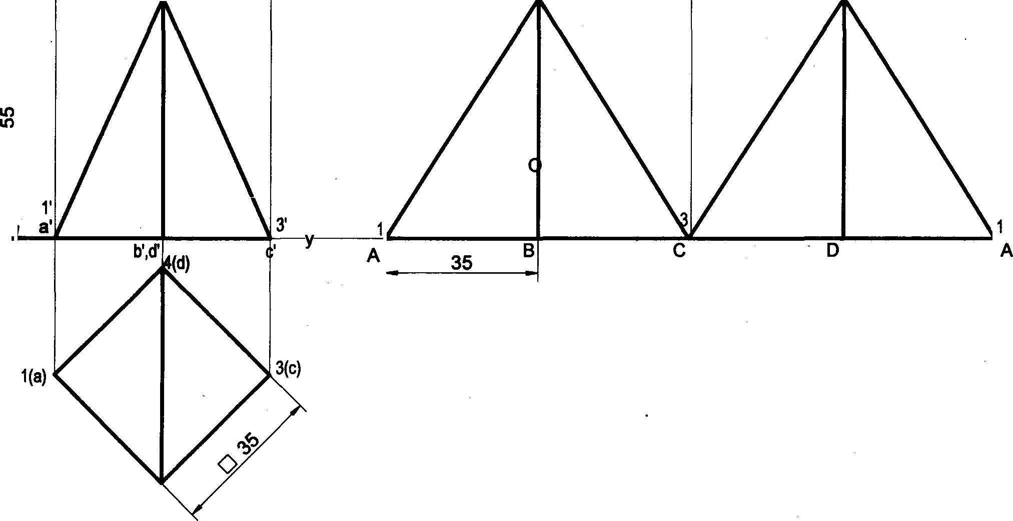

2,4'

2

y VP HP

2(b)

140

DEVEL PMENT

127

Problem 7 A rectangular prism of base 40mm x 25mm and beight 68mm resta on HP on its base with the longer base

side inclined «t go to vP. It is cut by a plane ircItr›ed at o to HP, perpendicular to VP cuts the axis at Its mid helght. ,

Draw the development of the remaining portion of the prim

Solution



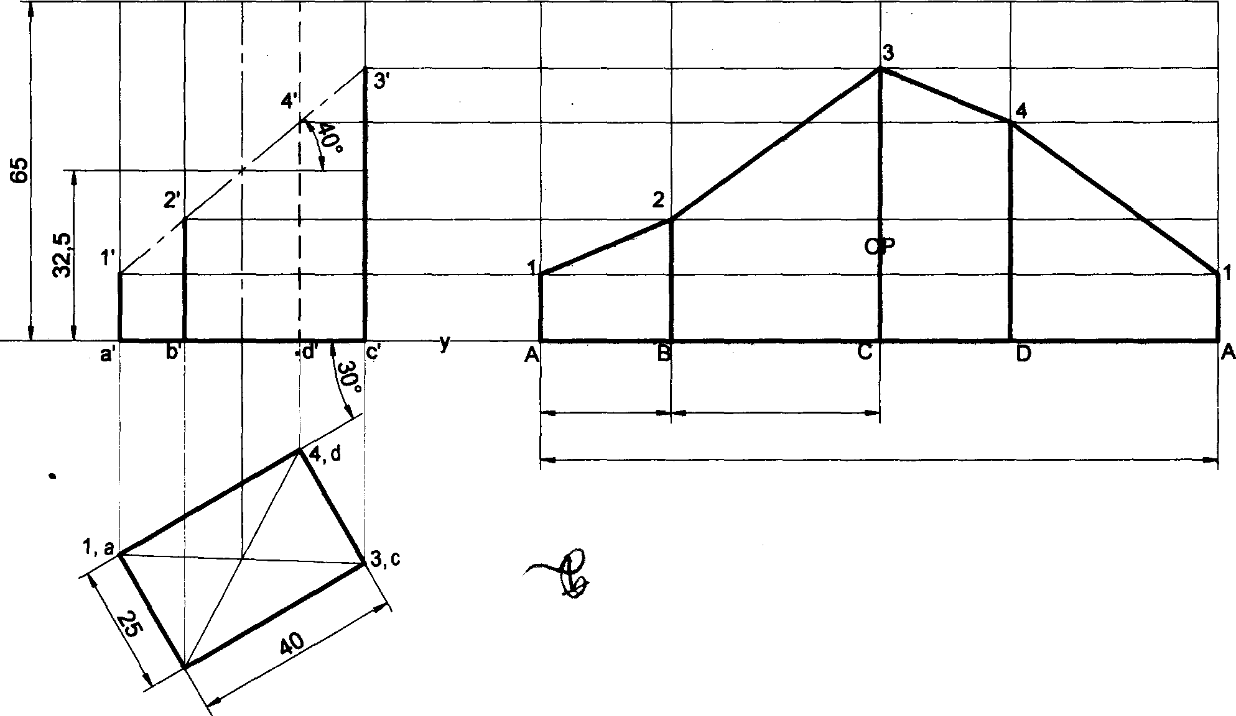

DEVEL MENT

VP HP

25

40

130

2, b

Problem 8 A rectangular prism of base 30mm x 20mm and height 60mm rests on HP on its base with the longer base side inclined at 40° to VP. It is cut by a plane inclined at45^ to HP, perpendicular to VP and bisects the axis. Draw the development of the lateral surface of the prism.

## Solution

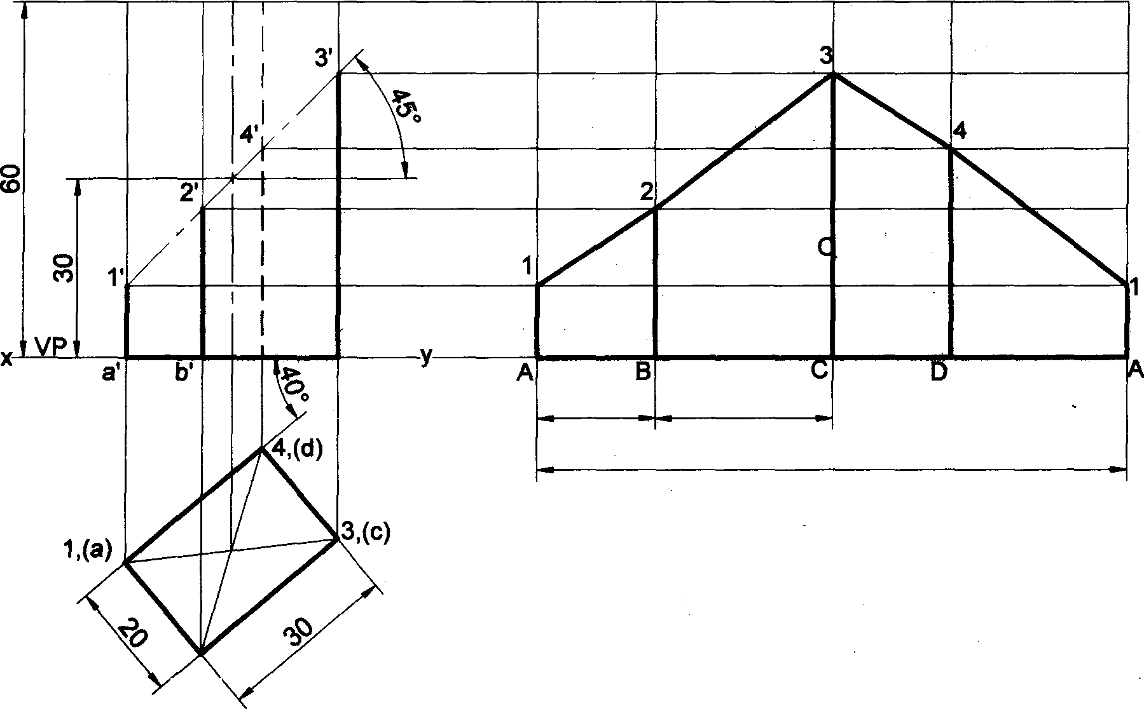

DEVEL PMENT

HP

d’

c’

,

20 30

100

128

” Preblam e A ‹»‹x«“” “ u p z so» x›•z‹r» ‹v›a i»1 6s « x›c‹s • ne •r› z• a•+•

aa leepr aias al aa¥a i/ałna4 at ażr a vP. it ua 4 a ąaaaaaea a‹o• an» af<i Peża•aoa«a'?P a•o

pss86ś thróugh th6 8xtreme left cofnsr of base. Óraw tń6 devełopment ofthe lateral surłśce óftfłs/er/tałfi¥›gpóft¥›riof

me prtsm.

# 9eIutIon

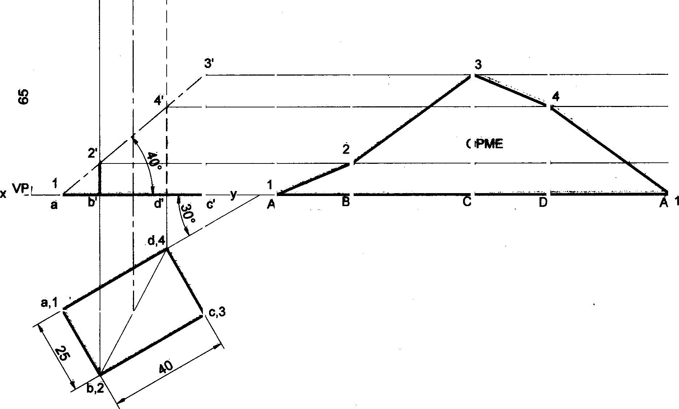

HP

|  |  |  |  |
| --- | --- | --- | --- |
| 25 | DEVEL  40 | NT  25 | 40 |

Pżoółefh 19 Drawthe Oevełópment of the truncated porśon óf Bis lateral faces of a po tagonałpricfn of 2&r›m eides ót basś and 50mrń h&ight standłng vartically włth óne óf its rectangułaż faces erallól tó VP afld eaf f& k só śE t¥ ptodtxe a one piace development. The inclinśd face of the tfuncated prism is 3D• ło ile adezdtd gaesśs throci§łt the ńght extrema cómór of the top face of the prism.

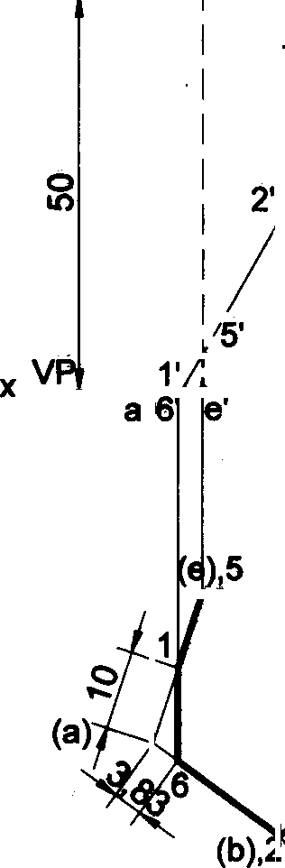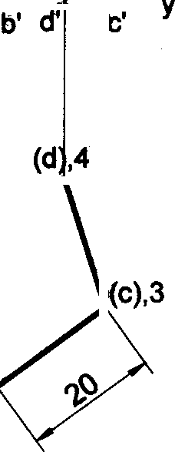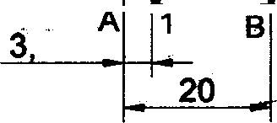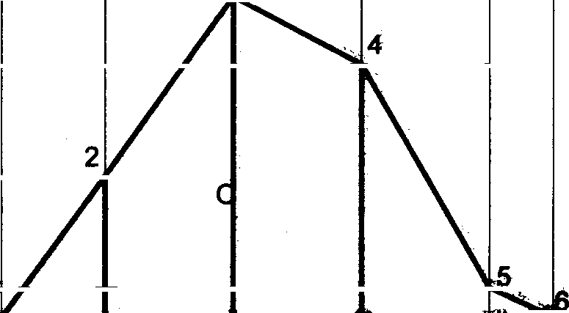

DEVEL PMENT

HP

83

E" “

10

3’

A

129

**Problem 11 A** regular pentagonal prism of height 60mm and base edge 30mm rests with its base on HP. The vertical face closest to VP is 30° to it. Draw the development of the truncated prism with its truncated surface inclined at60• to its axis and bisecting it.

09

##### Solution

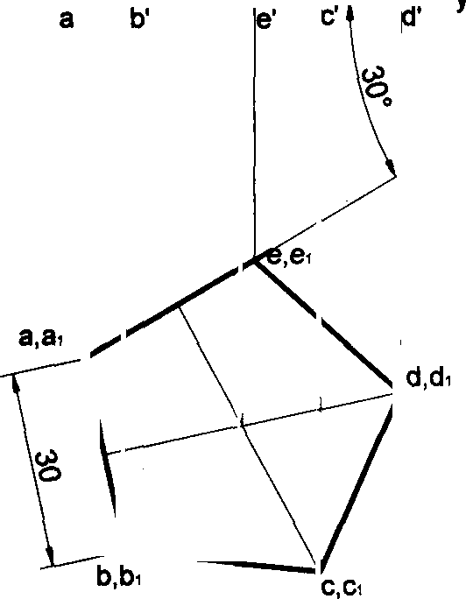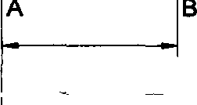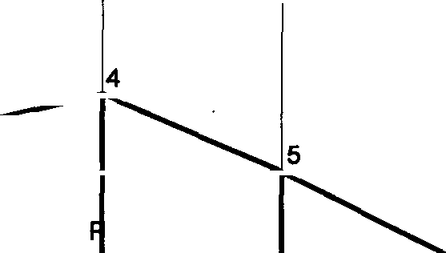

a›' b ’

e‹' c‹’ d.' A

B‹

E

A

4’

2

DEVELO MENT

VP HP

30

A

150

1

l

2'

**Problem 12 A** pentagonal prism of 30mm side of base and height 50mm lies with is base on HP such that one of the

rectangular faces is inclined at 40° to VP. It is cut to the shape of a truncated pyramid with the truncated surface inclined at o to the axis so as to pass through a point on it 30mm above the base. Develop the truncated portion of the prism

so as to produce a one piece development.

##### Solution

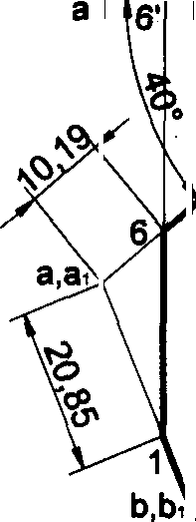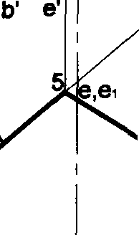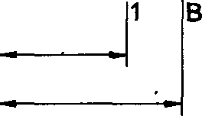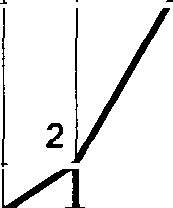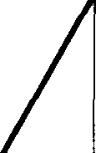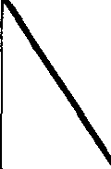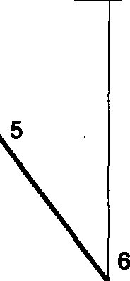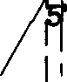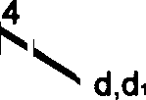

a ' b‹’ e›' 3'4' c‹' d '

A•

B•

3 C‹

D•

4

E‹

DEVELOPME T

150

20.85

30

130

Problem 13 A pentagonal prism of base sides 30mm and axis length 60mm rests with its base on HP and an edge of the base inclined at 450 to VP. It is cut by a plane perpendicular to VP, inclined at 400 to HP and passing through a point on the axis, at a distance of 30 mm from the base. Develop the remaining surfaces of the truncated prism.

Solution

a•' b•' e ' c ' d‹' A1

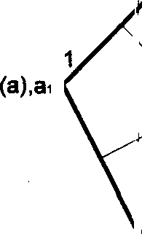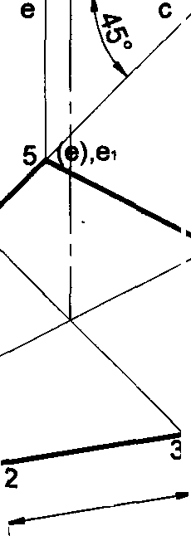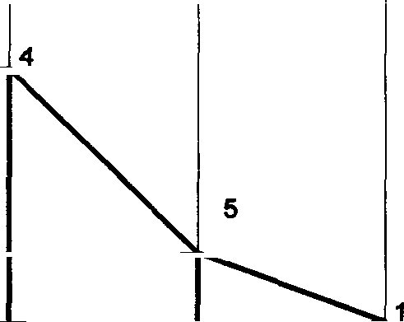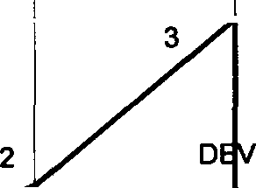

ELOPMENT

VP

HP

a' b

d' A)

D

E

A

30 B| ”

* (d),d

(b) ’'

to

I I

2

B1 C1

D1 E1 A1

y

Problem 14 A pentagonal prism of base sides 20mm and height 40mm is resting with its base on HP and base edge parallel to the VP. The prism is cut as shown in the following front view. Draw the development of the lateral surface of the prism.

Solution

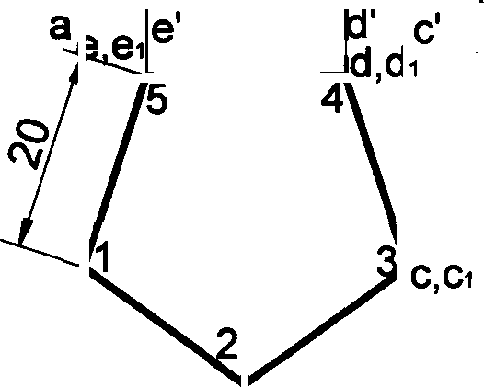

1

D VELOPM NT

VP

“ HP

b'

A

a,a1

100

E

B)

20

1

3 t

4Z

a›' e1' b1’ d›' C1'

20

A‹ B1 C1,3 D› E› A1

b,b1

131

Problem 15 A hexagonal prism of base side 20mm and hei@I 50mm is resting on HP on its base, sudh that one of its base edge is parallel to VP. The prism is cut in this position as shown in the following frerit vi0w. Drew the develop- ment of the lateral surface of the prism.

Solution

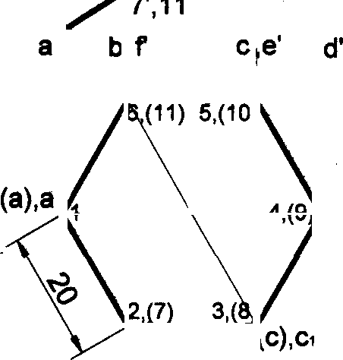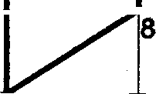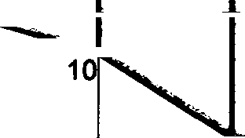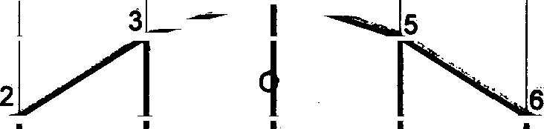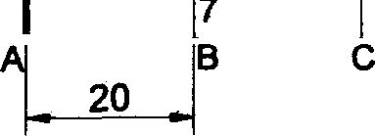

a ' b‹',f•’ c ',e '

3',5

d‹'

*'

A

B

C

D 4

E

F

OEVEL PhtENT

1

9'

1 t

VP( HP

D

E

F

i A

(d),d

(b),b

e),e

(f},f

8',10

2’,6

**Problem 16 A** hexagonal prism of base side 25mm and height 55mm is resting on HP on its base, such that one of its base edges is parallel to VP. The prism is cut in this position as shown in the following front view. Draw the develop- ment of the lateral surface of the prism.

##### Solution

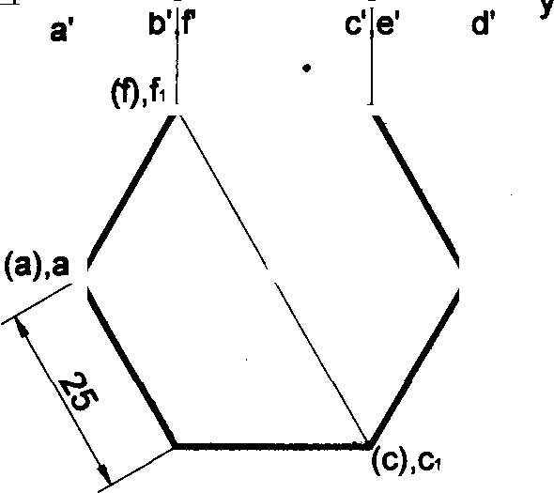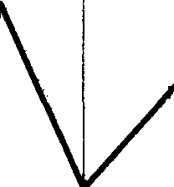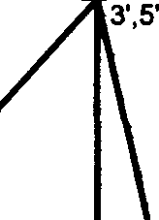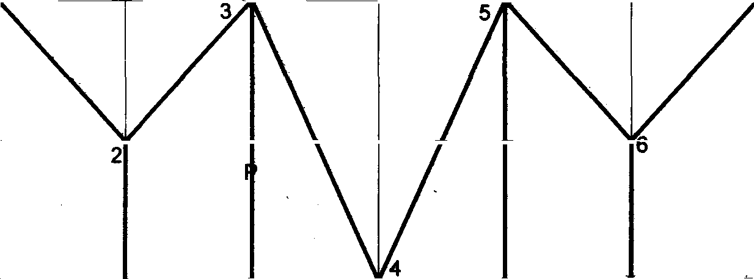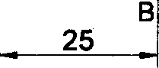

a'‹

1

b'•,fi

B‹

E›

F

DEVELO MENT

HP

A

(e),e›

(d),d

(b),b›

150

F

E

D

132

**Problem** 17 The Inside of a hopper of a flour mill is to be lined with thin sheet. The top and bottom of the hopper are regular pentagons with each side equal to 30 mm and 22.5mm respectively. The height of the hopper is 30rnm. Draw the shape of the sheet to which it is to be cut so as to fit into the hoppar.

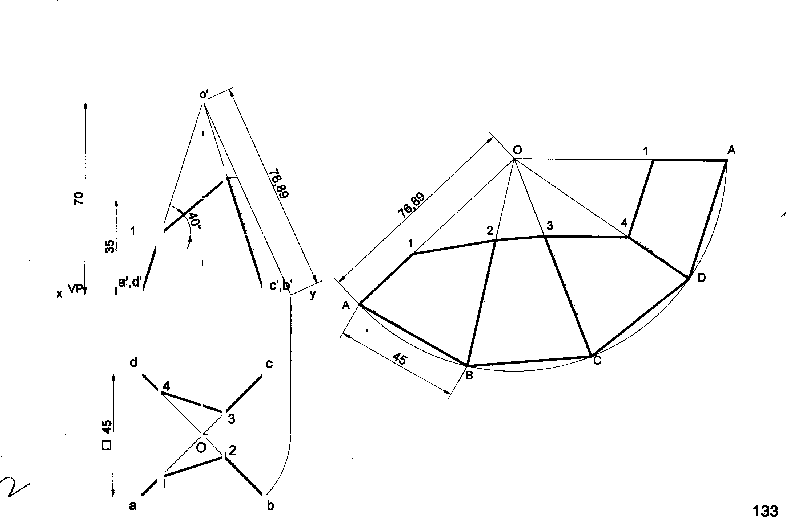

P lem 18 A square pyramid of side of base 45mm, altitude 70mm is resting with its base on HP with two sidas of he base parallel to VP. The pyramid is cut by a section plane which is perpendicular to the VPand itmlif edat'4'0• to the HP. The cutting plane bisects the axis of the pyramid. Obtain the development of the lateral surfaoes the truncated pyramid.

**Solution**

2,(3')

',(4')

OEVELOPMENT

HP

b1

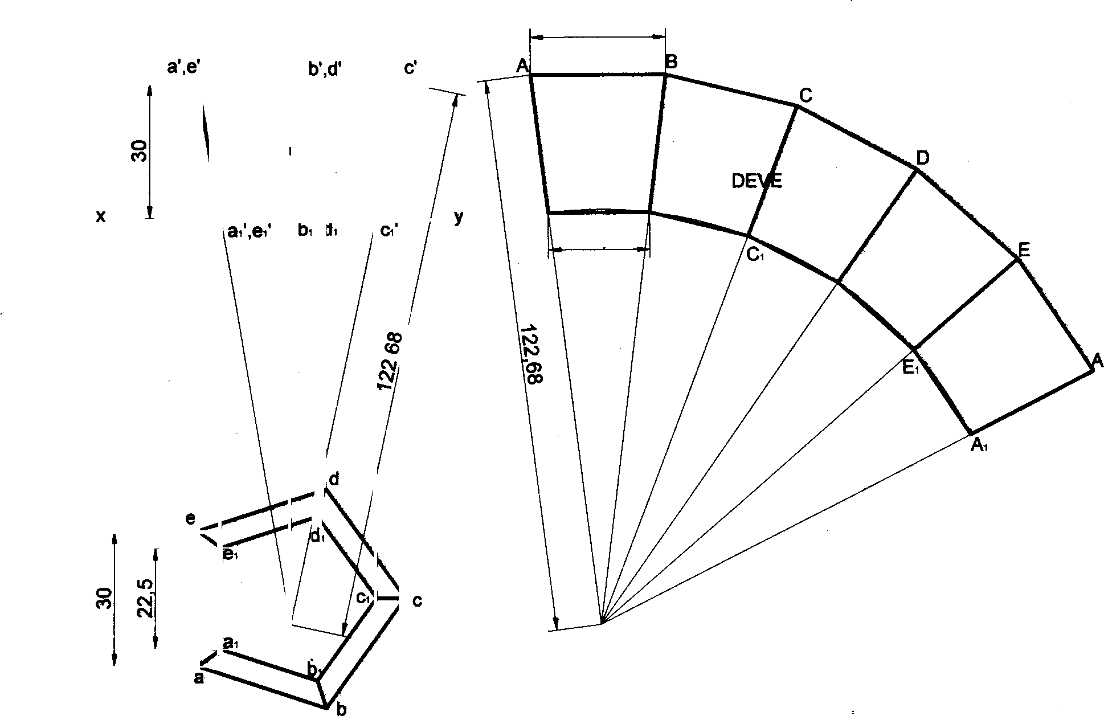

**Solution**

**30**

**LOPMENT**

VP HP

A

22.5

B•

D;

Problem 19 A square pyramid base 40mm side and axis 65mm long has is base on HP and all the edges of the base are equally inclined to VP. It is cut to with an inclined section plane so as the truncated surface at 45• to is axis, bisecting it. Draw the development of the truncated pyramid.

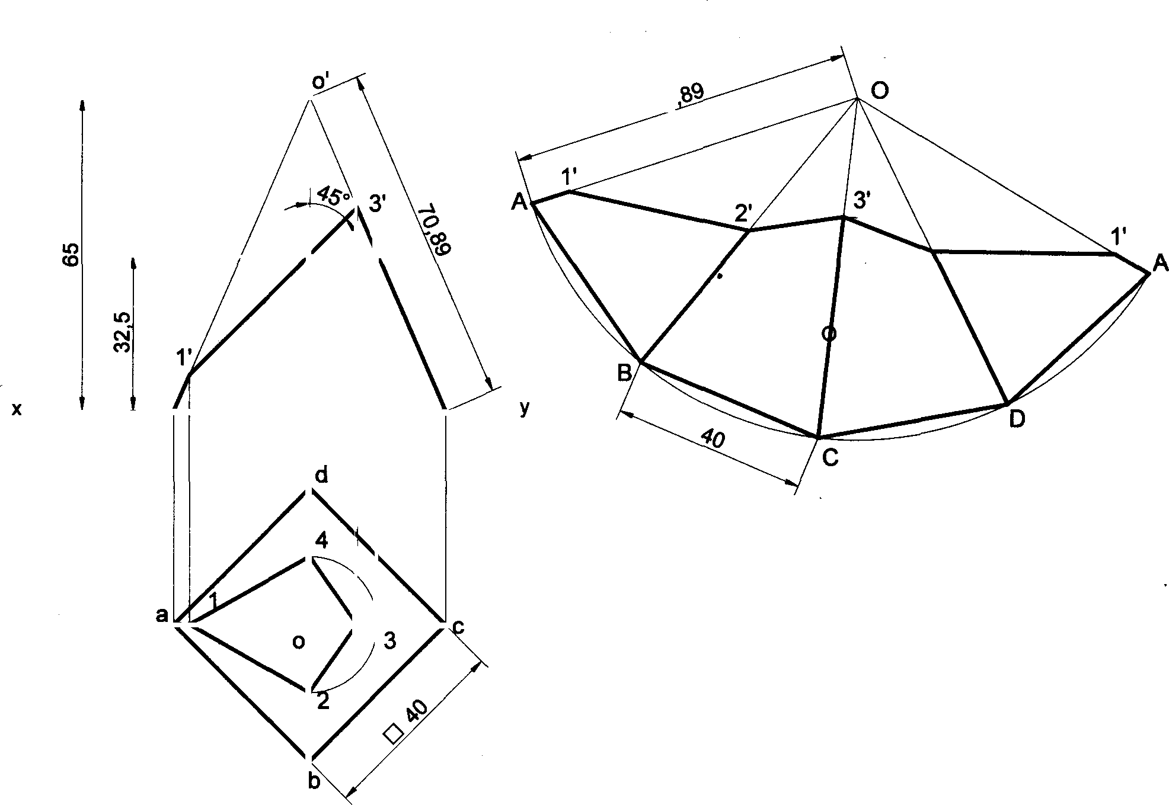

Solution

2',(4') 4'

DEVEL PMENT

VP HP

Problem 20 A frustum of a square pyramid has its base 40 mm sides, top 16 mm sides and height 60mm, its axis is vertical and a side of its base is parallel to VP. Draw the projections of the frustum and show the development of the lateral surfaces of it.

Solutlon

*”*

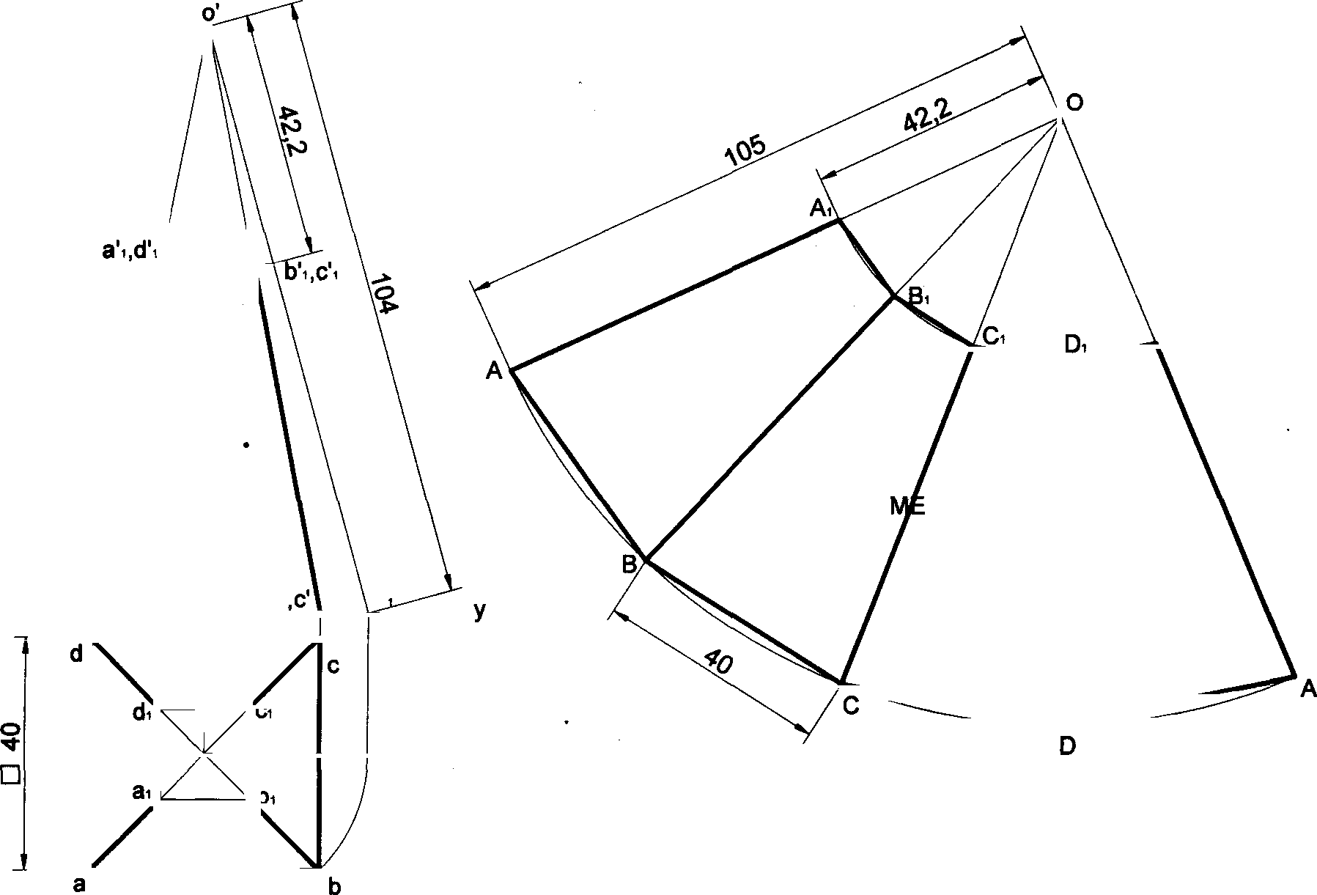

A‹

DEVELOP NT

vP a',d’ HP

b'

b'

b1

134

Problem 21 A square pyramid of 25mm base edge and 50mm height rests with its base on HP with all of its base edges equally inclined to VP. It is cut by a plane perpendicular to VP and inclined to HP at 60°, passing through the extreme right corner of base. Draw the development of the lateral surface of the pyramid.

### Solution

y y

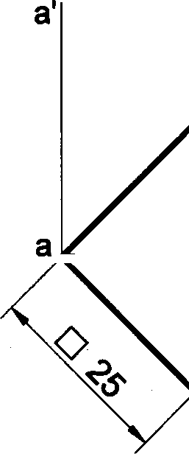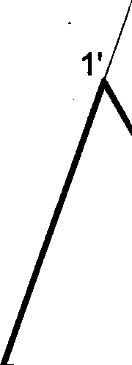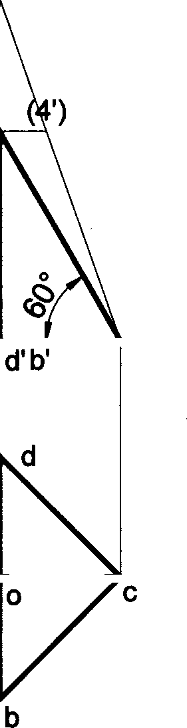

2'

VP HP

3’,c'

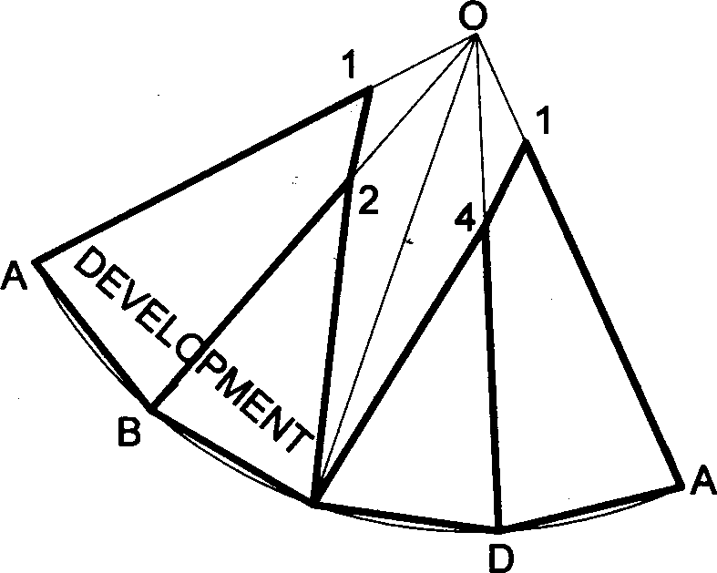

C,3

Problem 22 A rectangular pyramid, side of base 25mm x 40mm and height 50mm has one of the sides ot the base is inclined at W to the VP. Draw the development of the lateral surface of the cut pyramid, whose front view is shown below.

Solution

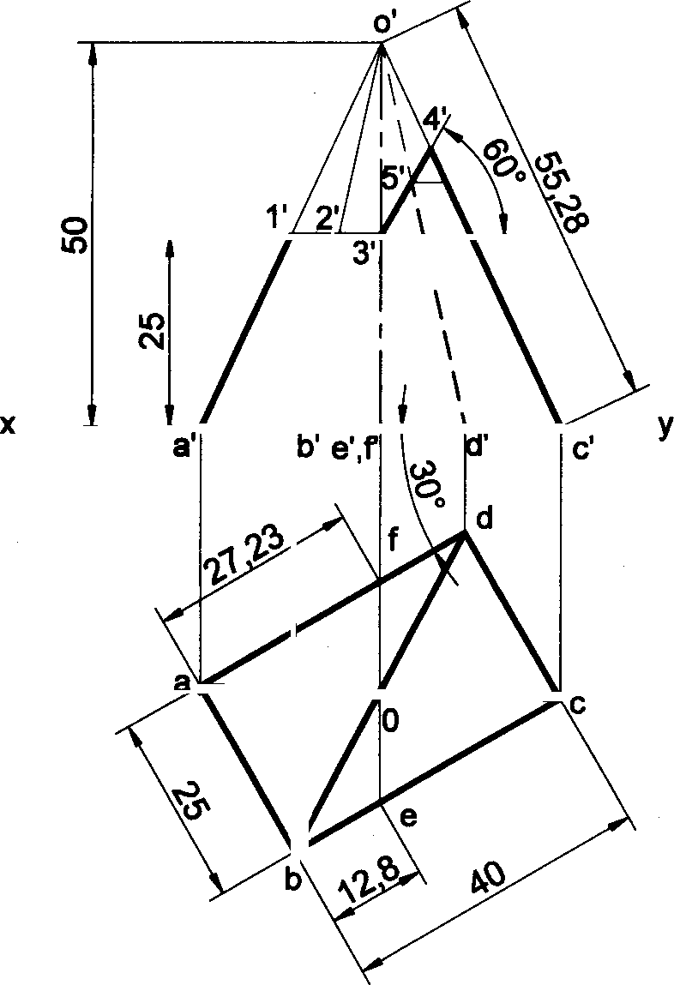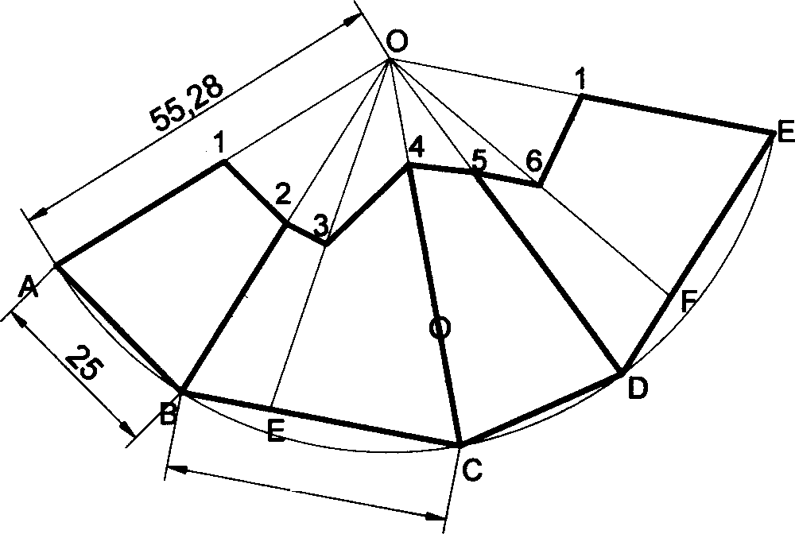

DEVEL PMENT

VP

HP

135

Problem 23 A frustum ofa pentagonal pyramid, smaller base sides 16mm and bigger top faoe sides 32mm and height 40mm, is resting on the HP on its smaller base, with one of its base sides parallel to the VP. Draw the pro}estions of the frustum and develop the lateral surface it.

Solution

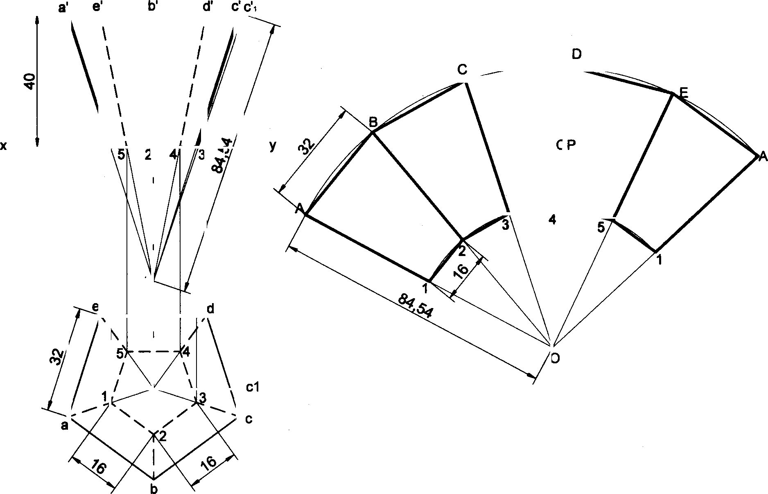

VP HP

DEVEL MENT

Problem 24 A regular pentagonal pyramid of side of base 35mm and altitude 65mm has its base on HP with a side of base perpendicular to VP. The pyramid is cut by a section plane which is perpendicular to the VP and inclined at 30° to HP. The cutting plane meets the axis of the pyramid at a point 30mm below the vertex. Obtain the development of the

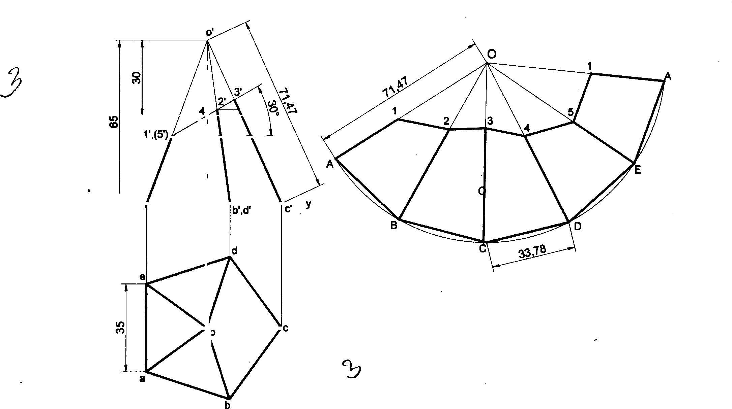

remaining part of the pyramid.

Solution

y VP )

HP a',e

DEVEL PMENT

136

**Problem 26 A** pentagonal pyramid, 30mm sides, with a 6ide of base perpendicular to VP. Draw the development of

the lateral surfaces of the retained portion of the pyramid shown by the dark lines in the following figure.

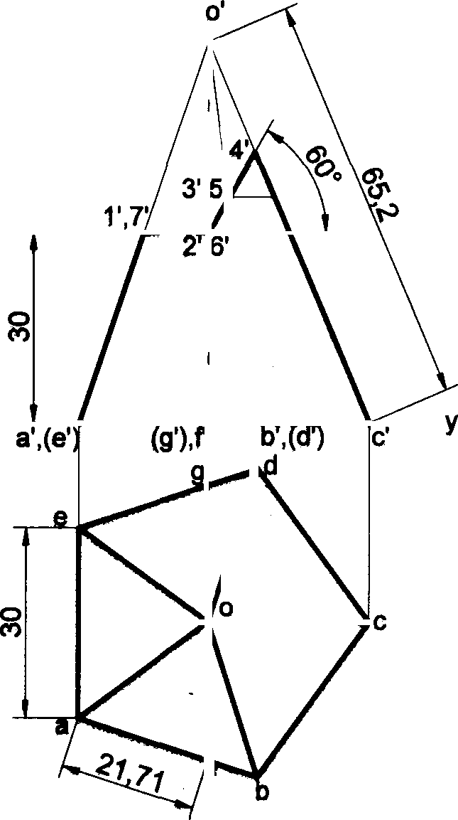

VP HP

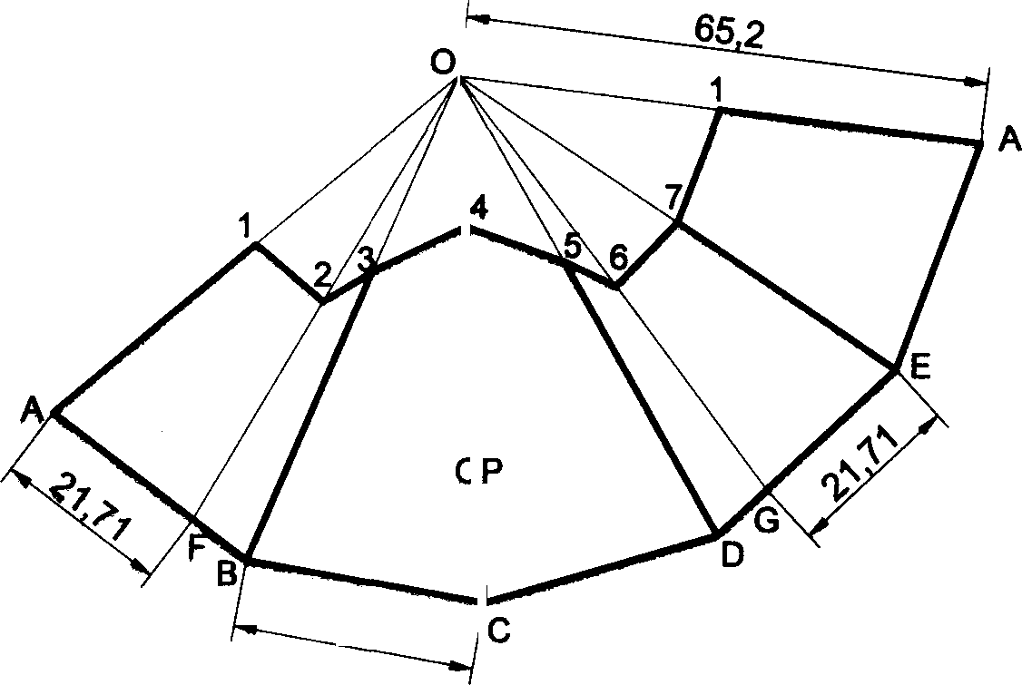

DEVEL MENT

Pl'oblem 26 A pentagonal pyramid of 30mm edges of base and 50mm height rests vertically with one of its base edges parallel te VP and near•r to it. It is cut as shown in follewing figure. Draw the development of the lateral surfaces of the ugper pettion of the pyramid.

## Solution

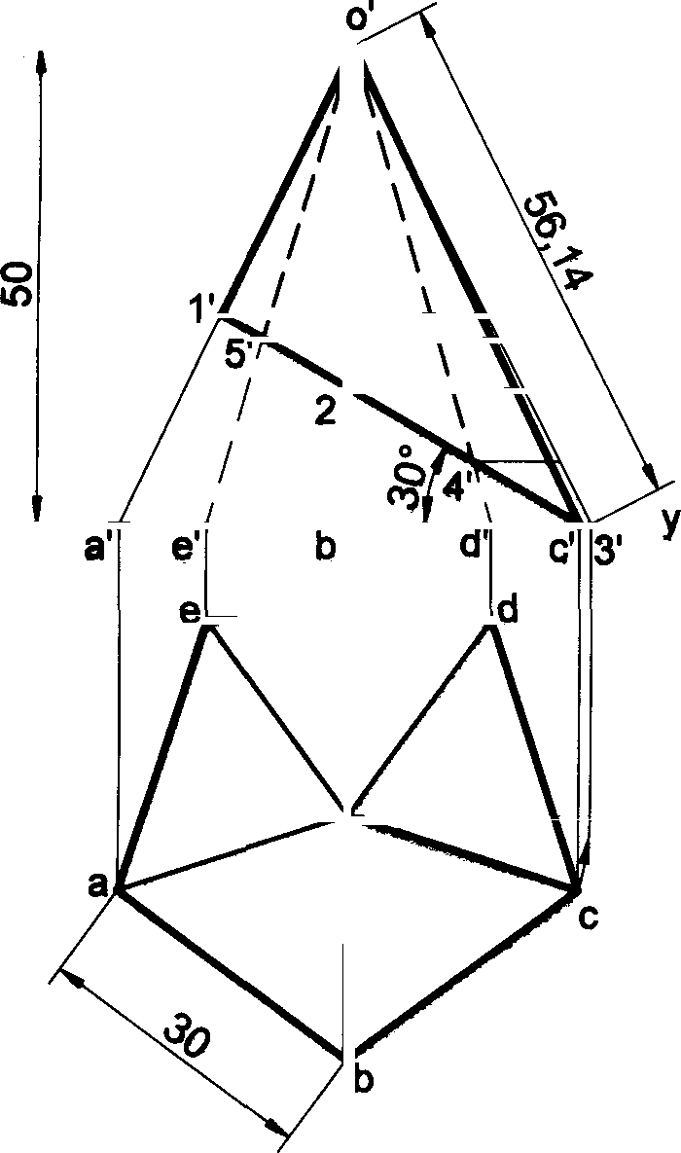

VP

HP

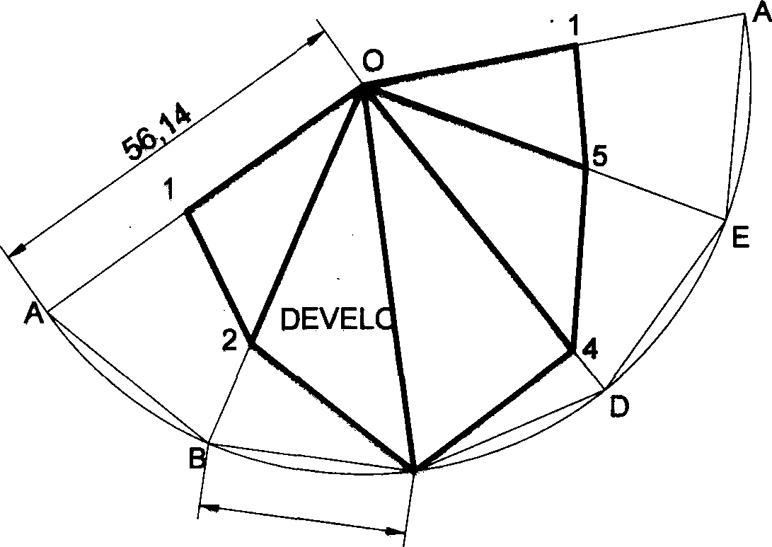

PMENT

137

Problem 27 A hexagonal pyramid, base sides 25mfh and height 60mm, is resting with its base on HP andean edge ol base inclined at 40° to VP. It is cut to the shape of a truncated pyramid with the truncated surface indicated in the fronl view at a point on the axis 20mm from the apex and inclined at 40° to XY. Draw the projections and show the developrnertl of the lateral surface of the remaining portion of the pyramid.

## Solution

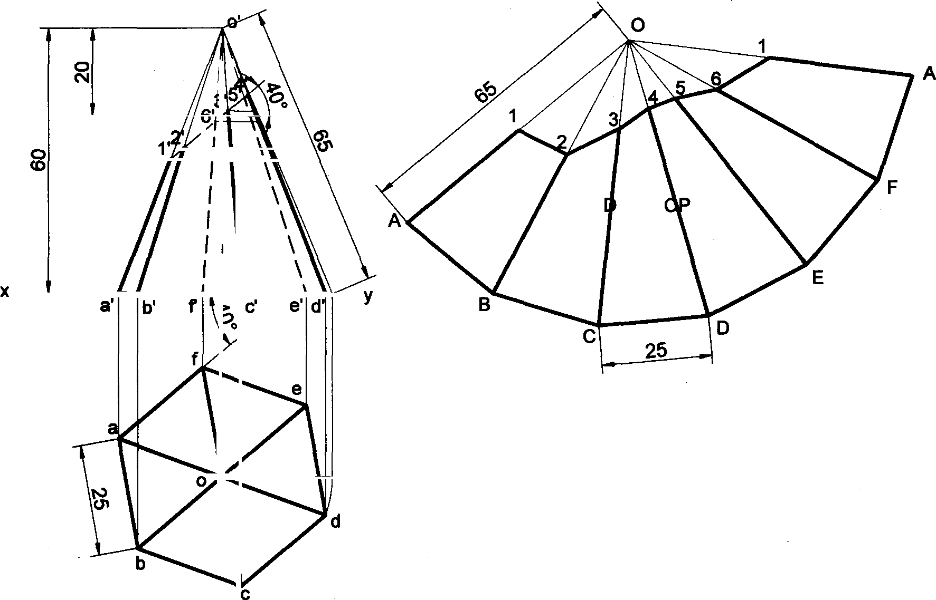

EVEL MENT

VP HP

Problem 28 A hexagonal pyramid of sides 35mm and altitude 65mm is resting on HP on its base with two of the base sides perpendicular to VP. The pyramid is cut by a plane inclined at 30° to HP and perpendicular to VP and is intersecting the axis at 30mm above the base. Draw the development of the remaining portion of the pyramid.

#### Solution

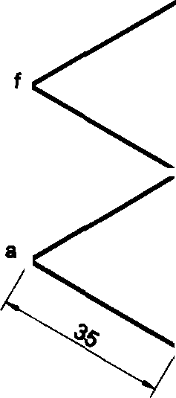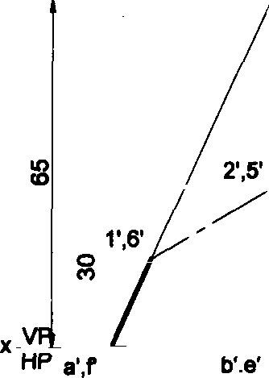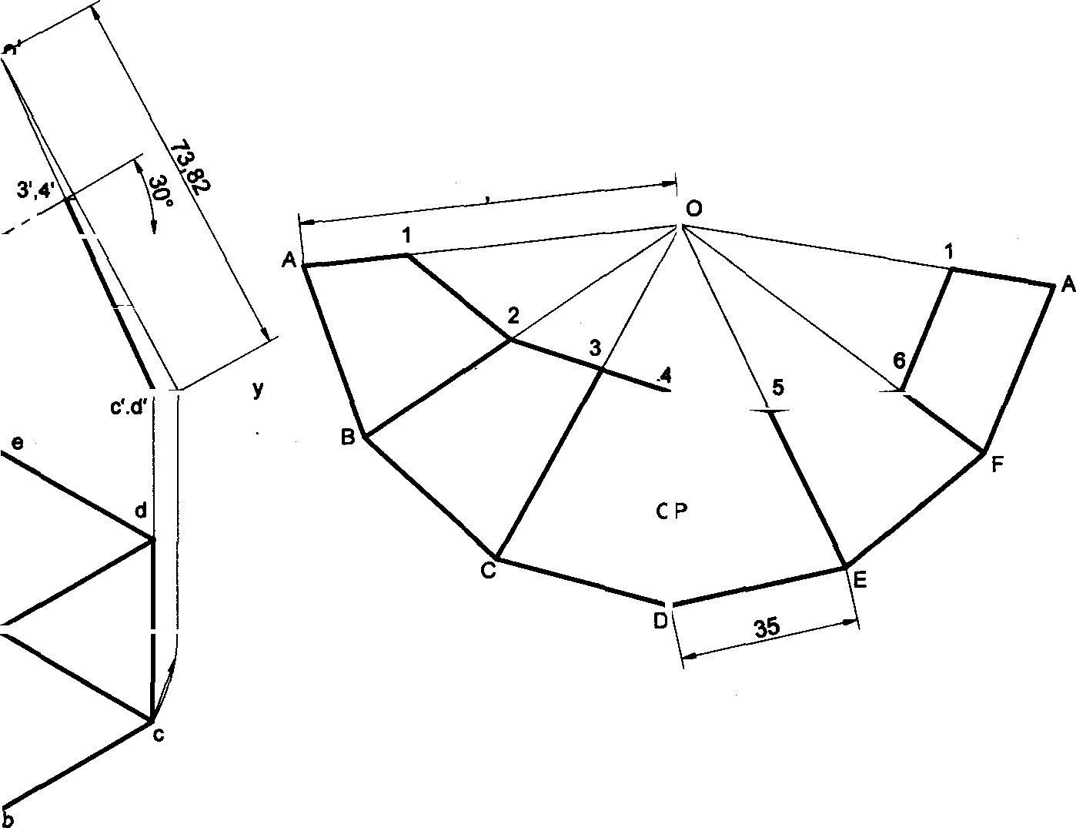

73 82

DEVEL MENT

138

Ptoblem 29 A hexagonal pyramid 25 mm side of base and axis 65 mm long is resting on its base on HP with one of the edges of the base parallel to VP. It is cut by a vertical section plane at a distance of 8 mm from the a›tis towards right side. Develop the lateral surface of the left part of the pyramid.

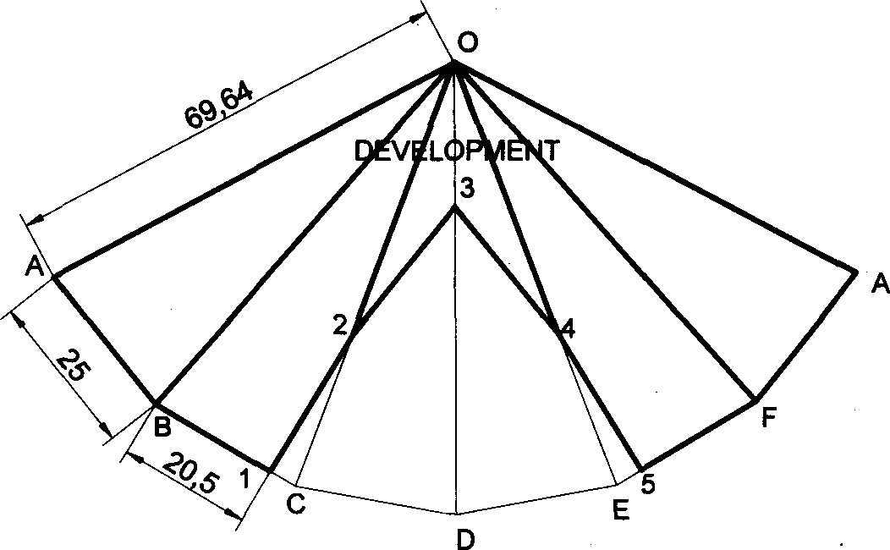Solution

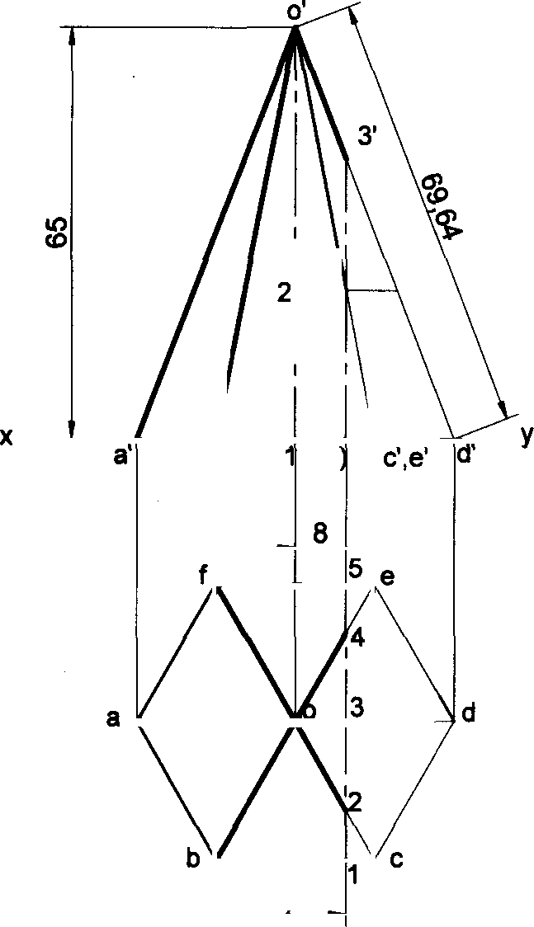

,(4’)

HP

b’,f

’.(5’

20.5

25

Problem 30 A hexagonal pyramid of 30mm base sides with a side of base parallel to VP. Draw the development of the lateral surfaces of the retained portions of the pyramid cut by two perpendicular planes shown by dark lines in the Fig.

#### Solution

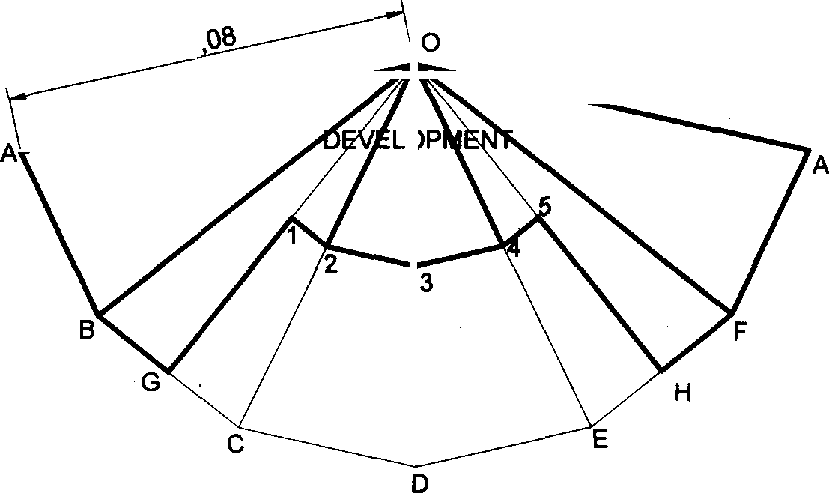

6/.

139

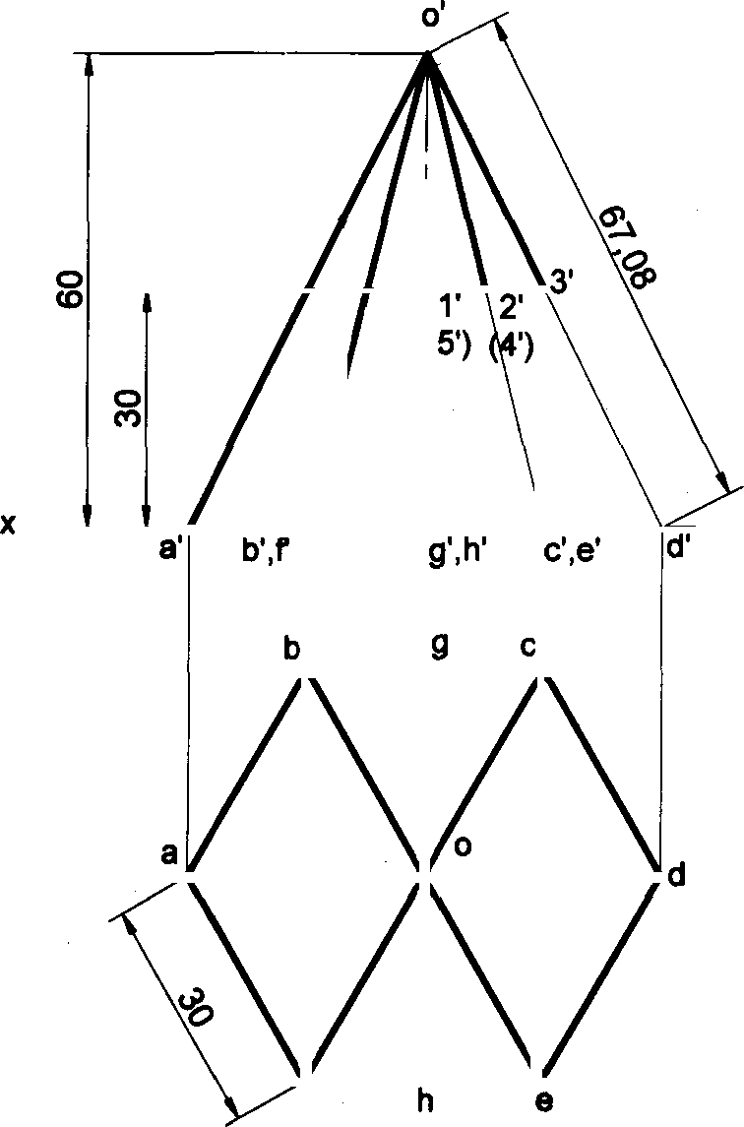

VP HP

**Problem 31 A** vertical cylinder of base diameter 45mm and axis length 60mm is cut by a plane perpendicular to VP and inclined at 500 to HP, is passing through the centre point of the top face. Draw the development of the lateral surface of the cylinder.

##### Solution

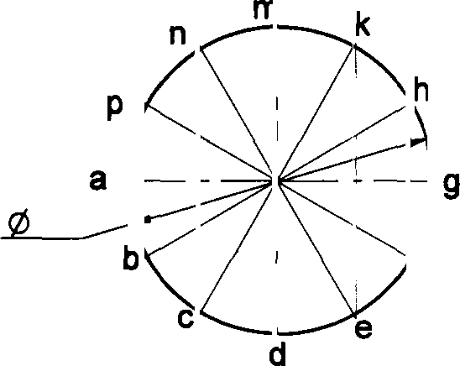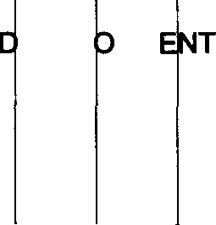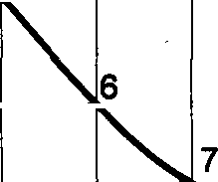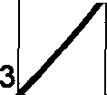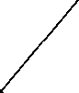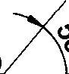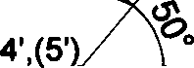

141,36

2',(7

1

VP HP

a' b',p c',n' d',m' e' k

f’ h

g’

A B C D E F j3 H K M N P’

A

45

EVEL PM

1

,(6’)

5

4

**Problem 32** Following figure shows the front view of a model of a steel chimney of diameter 60mm made from a flat thin sheet metal fitted over an inclined plane roof. Develop the portion of the chimney.

**Solution**

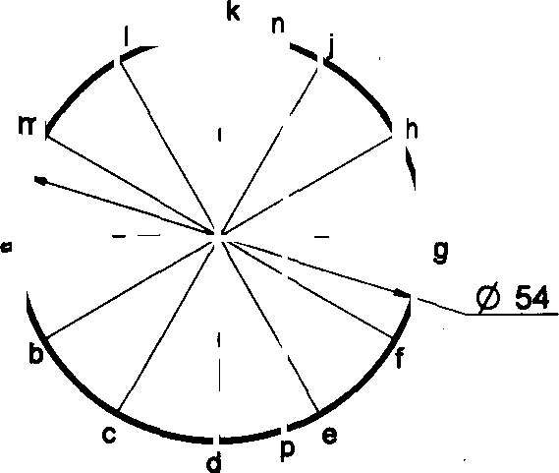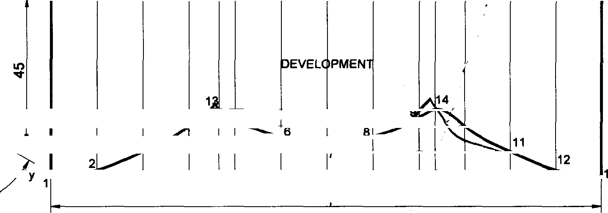

96

a' b’ I' C’ k’ d' j'

e' i’ h’ I g’

A

B

C

F G

H

96

L

jyj A

13' 1*

10

HP 1

166 67

#### 140

Problem 33 A vertical cylinder of base diameter 50mm and axis length 60mm is cut by a two planes which are perpendicular to VP and inclined at 45° to HP and passing through either side the centre point of the top face. Draw the development of the lateral surface of the cylinder.

#### Solution

4’,(10')

4 10

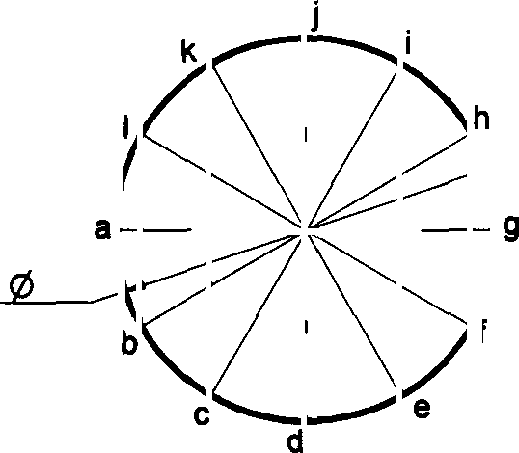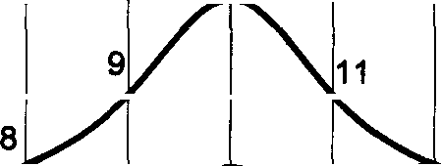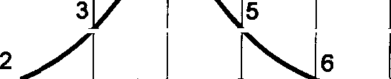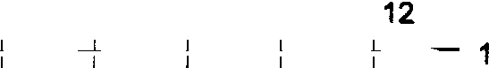

\',(11’ "”

'

’ '

V

HP a’ b',I'

i' f h g'

A

B

13,0§

C D E F G *

!

J K

L M

157,08

50

j' e

:’,k' d

7

EVEL PME T

1

7’

(8')

6

5'.(*')

P

',(1

1

Problem 34 A pipe made of using a half tubular (circular) with a half square in shape is cut as shown in the following

figure. Draw the development of the lateral surface of the object.

#### Solution

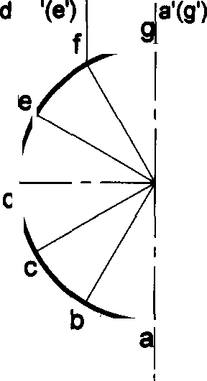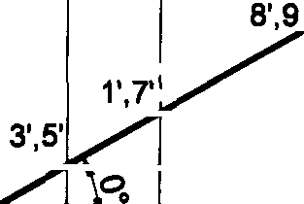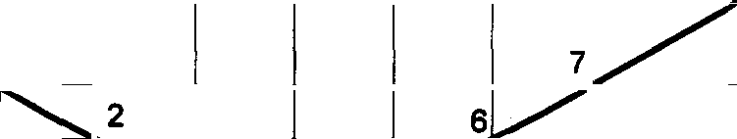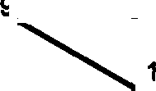

2

4

EVELf)

VP

HP

b'(r)

j’(h’) *

B C D E F e|

78,54

20

20

50

20 H

13,09

,

PMENT

1

6

141

Problem 35 Develop the lateral surface of the cylinder of 40mm diameter and height 60mm which is cut in the

following way.

Solution

‘•

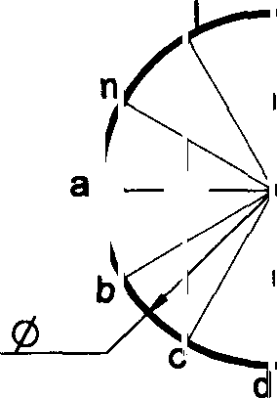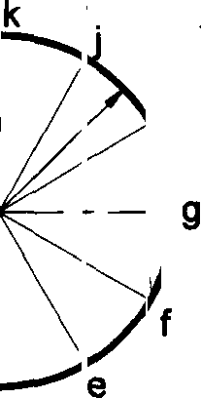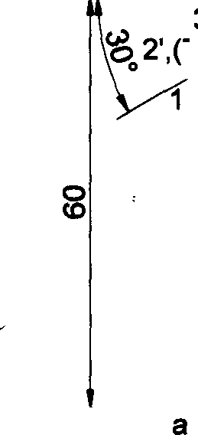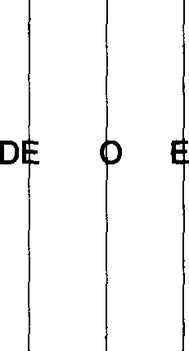

4', ’5’)

5

3',(6'

1

y VP HP

b' c' a

(m') (I') (k')

e’ g'

{j') '

*A*

A

40

H J K L M

F G

1256

B C D E

VEL PM NT

Problem 36 A cone of base diameter 60mm and height 70mm is resting on its base on HP. It.is cut as shown in the following figure. Draw the development of the lateral surface of the remaining portion of the cone.

#### Solution

g

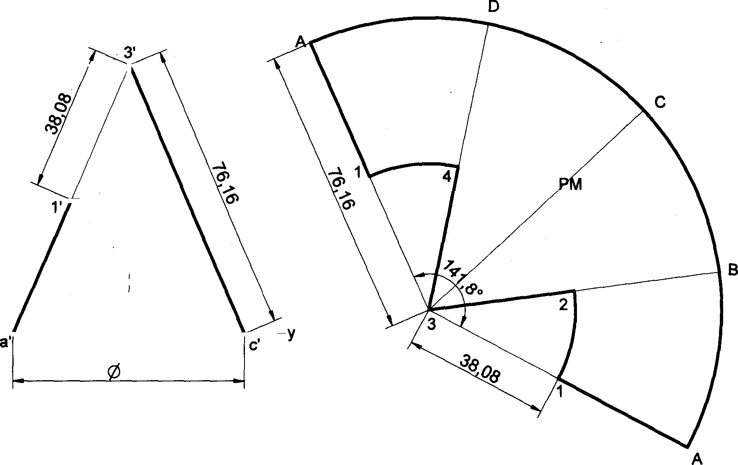

DEVELO ENT

2’,4’

VP HP

b’d'

60

142

Problem 37 Develop the lateral surface of the cylinder of 40mm diameter and height 60mm which is cut in the following way.

#### Solution

12 12

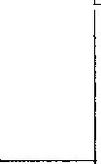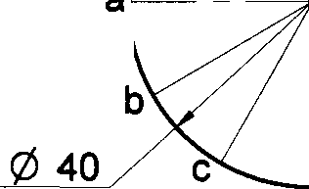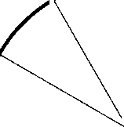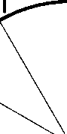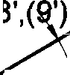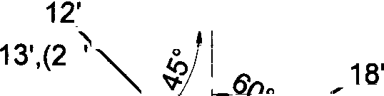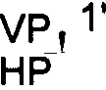

’,(21’

(7')

5, I’,(8"

)

14,

21

D VEL PM NT

6

15

6’

22’

1'

x

,(11

a' t’,I'c ,k' d ,j' e’,i

k

!

1

|

j

11

f,h ‹ y A

J K L M ,

F G H

125,68

B C D E

.

-

I

in

#### a

b f

@ 40 c e

d

Problem 38 A cone of base diameter 60mm and height 70mm is resting on its base on HP. It is cut as shown in the following figure. Draw the development of the lateral surface of the remaining portion of the cone.

#### Solution

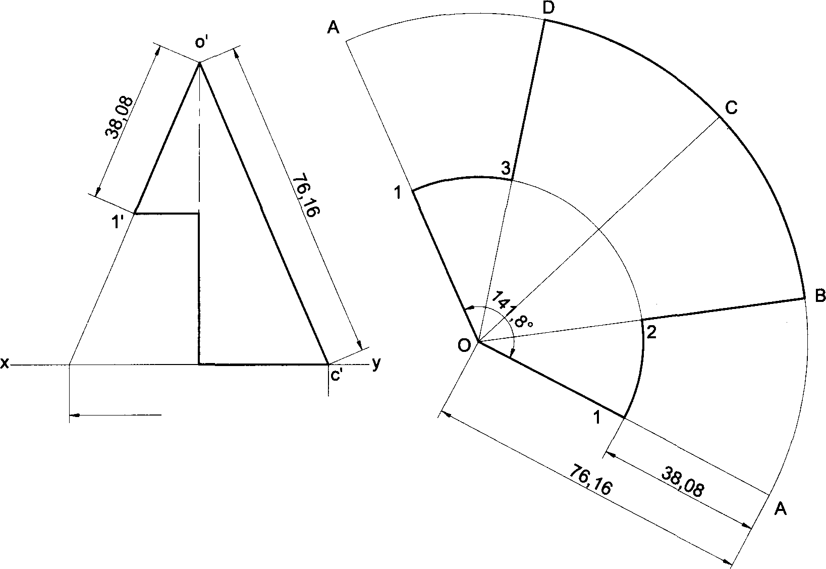

2',3’

DEVELOPMENT

VP HP a'

b',(d')

0

143

Problem 39 Draw the development of the lateral surface of a truncated vertical cylinder, 40mm diameter of base and height 50mm, the truncated flat surface of the cylinder bisects the axis at 60° to it.

Solution

A

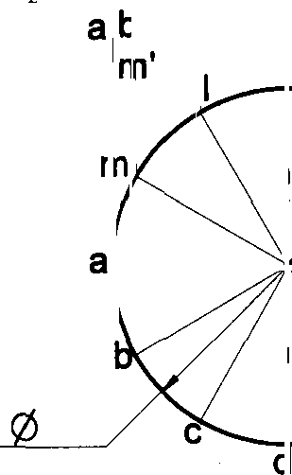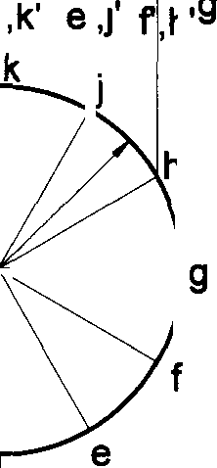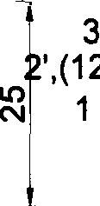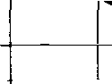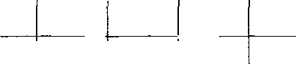

,(8')

*7'*

x _VP

HP

, c ,I' d

y

40

A B C D E F G H J K L M

125,68

D VEL PM NT

11’

10

|

4

(10'

4,

Problem 40 Develop the lateral surface of the cylinder of 40mm diameter and height 60mm cut in the following way.

Solution

1

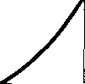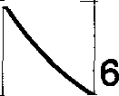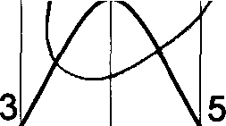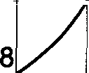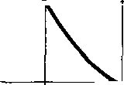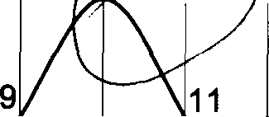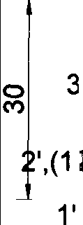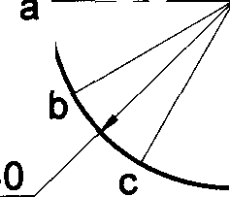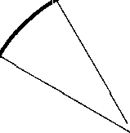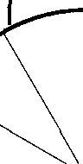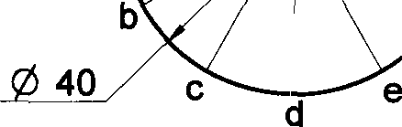

4',(10’)

VP i HP

a’b’, c I'

d k' e j' § 'U' k

#

C D E F = H J

K L M

rn

h

125.66

a

f

i\

10,47

M NT

7

D VEL DP

7'

1

12

2

,(8')

6f

\

5',(*

11'

A

144

Problem 41 A right cone of 55mm diameter of base and 75mm height stands on its base on HP. It is cut to the shape of a truncated cone with its truncated surface inclined at 45° to the axis lying at a distance of 40mm from the apex of the cone. Obtain the development of the lateral surface of the truncated cone.

##### Solution

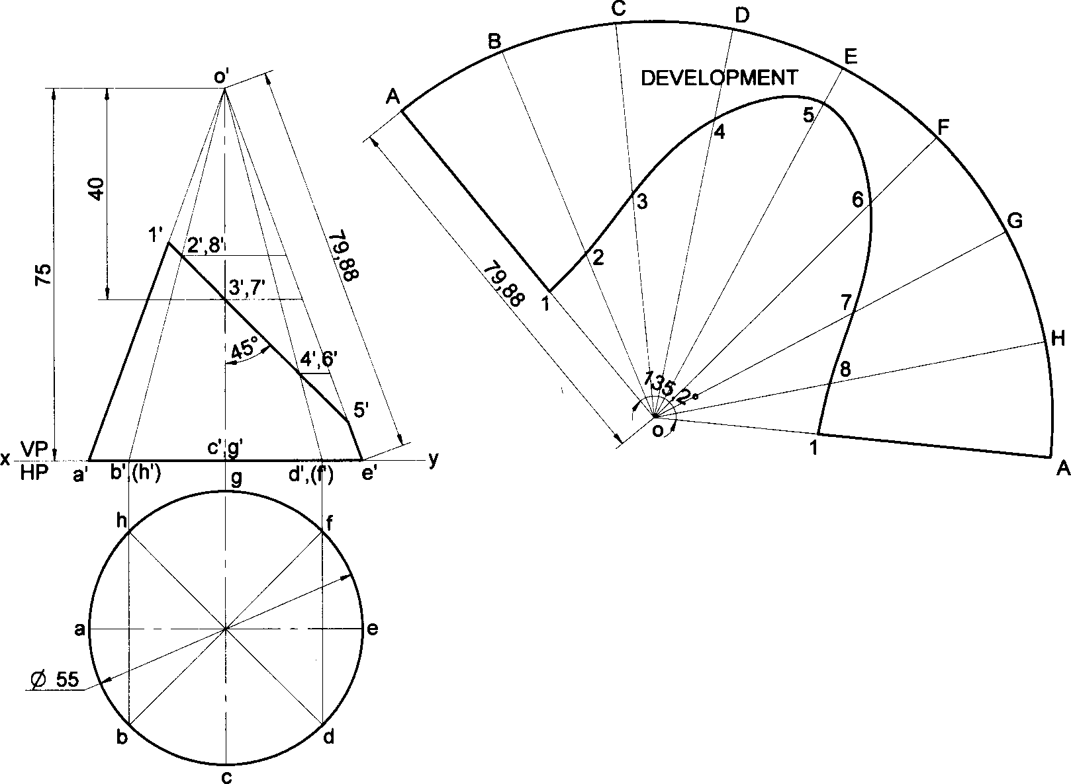

Problem 42 Draw the development of the following truncated cone.

##### Solution

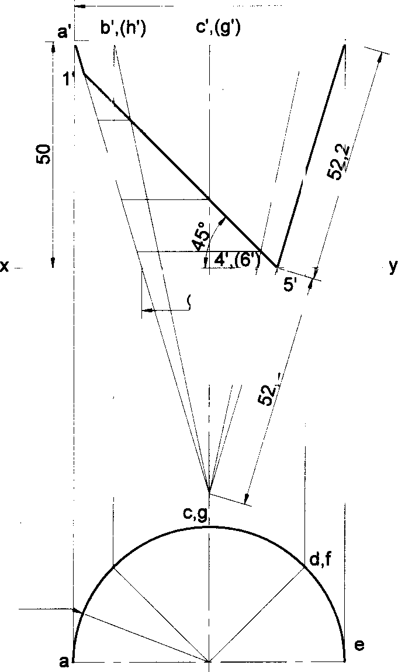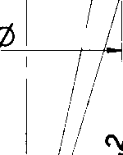

60

d',(f)

e

2’,(8’)

3',(7’)

VP HP

b,h

R 30

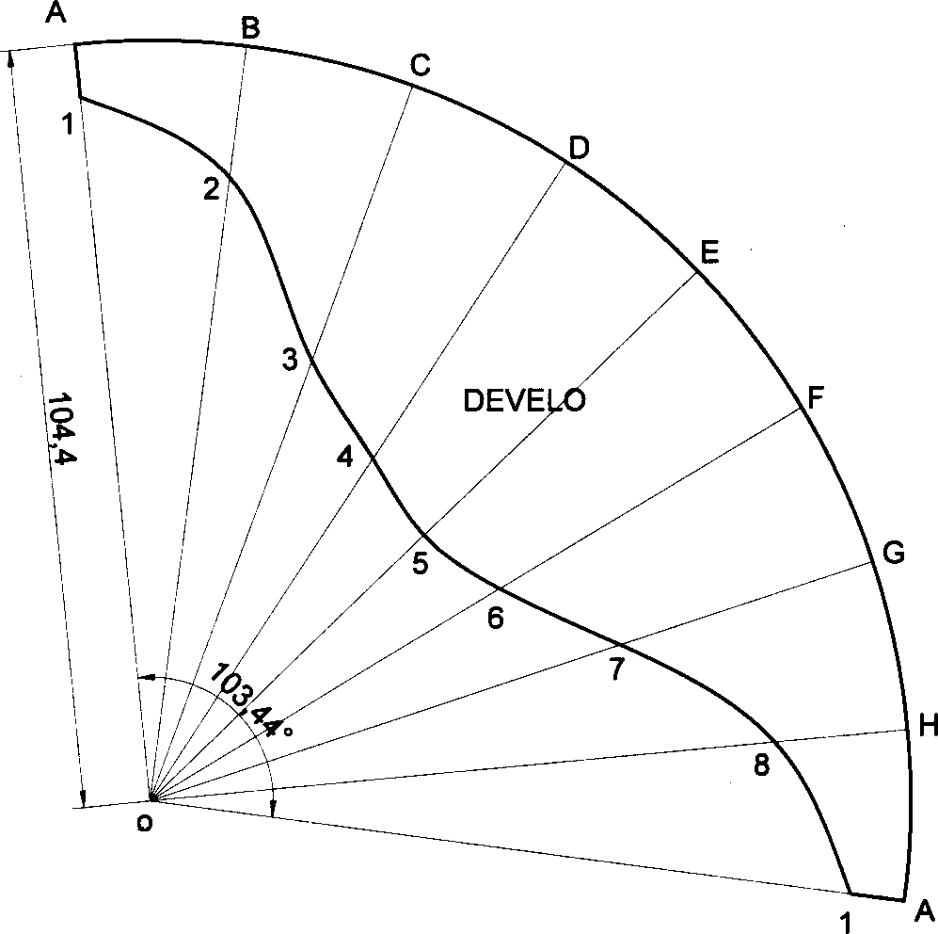

PMENT

145

Problem 43 A hexagonal pyramid of 30mm sides of base with a side of base parallel to VP. Draw the development of

the lateral surfaces of the retained portion of the pyramid which is shown by dark lines in the following figure.

Solution

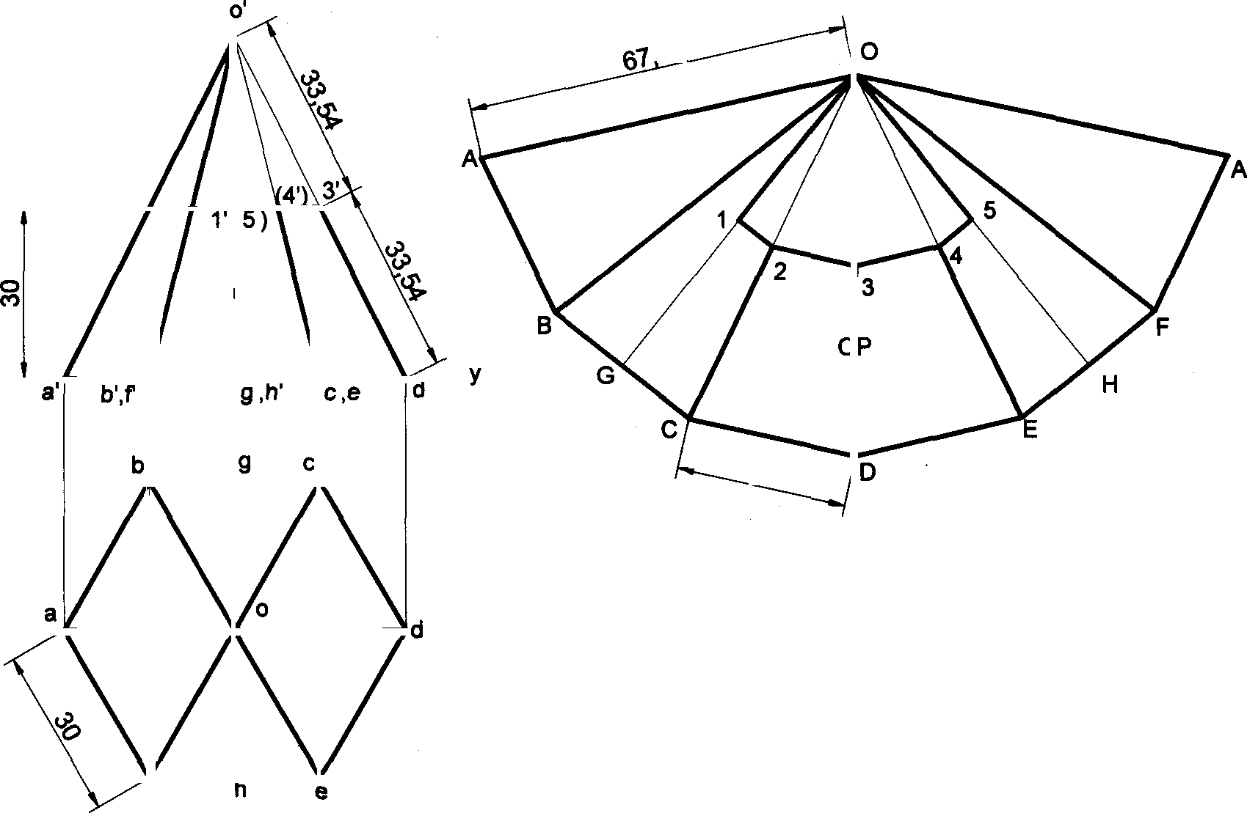

2'

VP HP

DEVEL MENT

Problem 44 Develop the lateral surface of the cylinder of 40mm diameter and height 60mm which is cut in the following way.

Solution

1

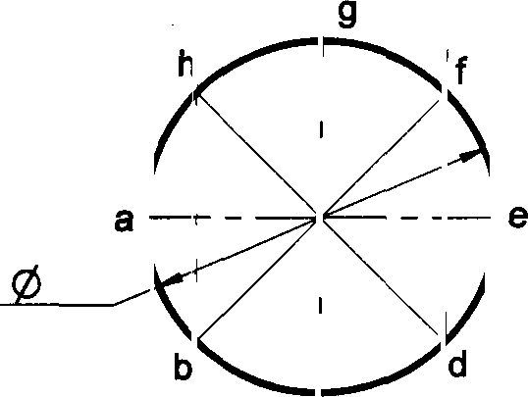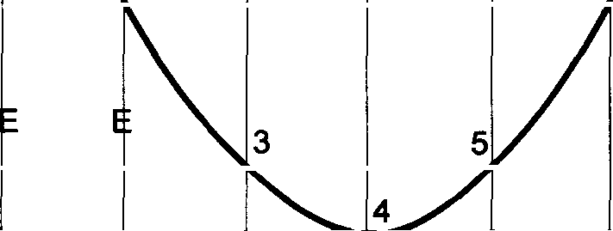

125,66

1',(7’)

DEV LOPM NT

VP

HP a b ,h’ c,g’ d I' •’

A

B

C

D

E

F

G

H

y

40

4'

5’)

3',

2',(6')

7

1

*

146

Problem 45 Draw the development of the lateral surface of the cone, whose front view is as shown in the following

figure.

#### Solution

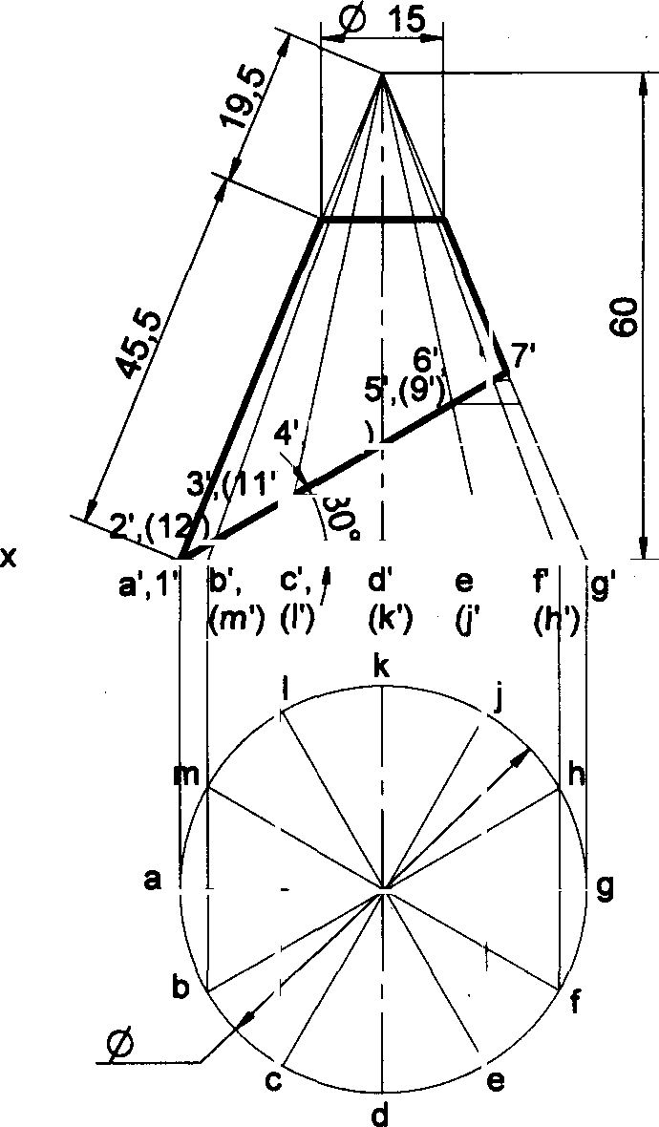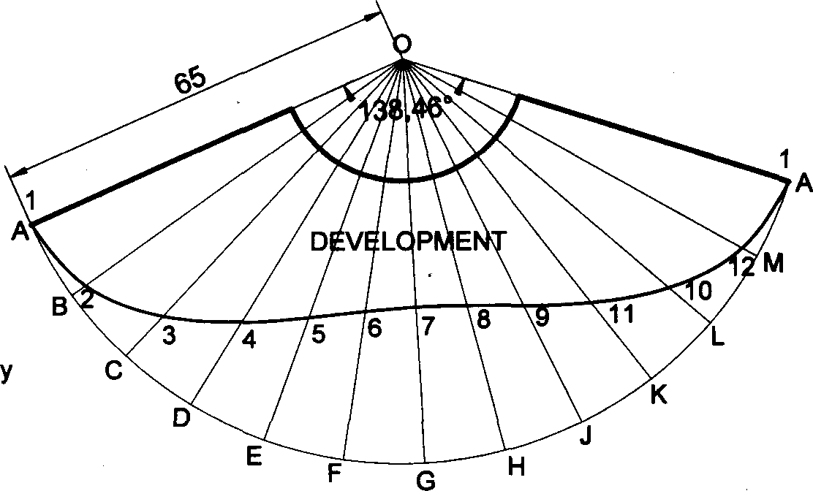

(8

(10’

VP

HP

50

Problem 46 A cone of base diameter 50mm and height 60mm is resting with its base on HP. It is cut, as shown in the

following front view of which is as shown in figure. Draw the development of the lateral surface of it. Solution

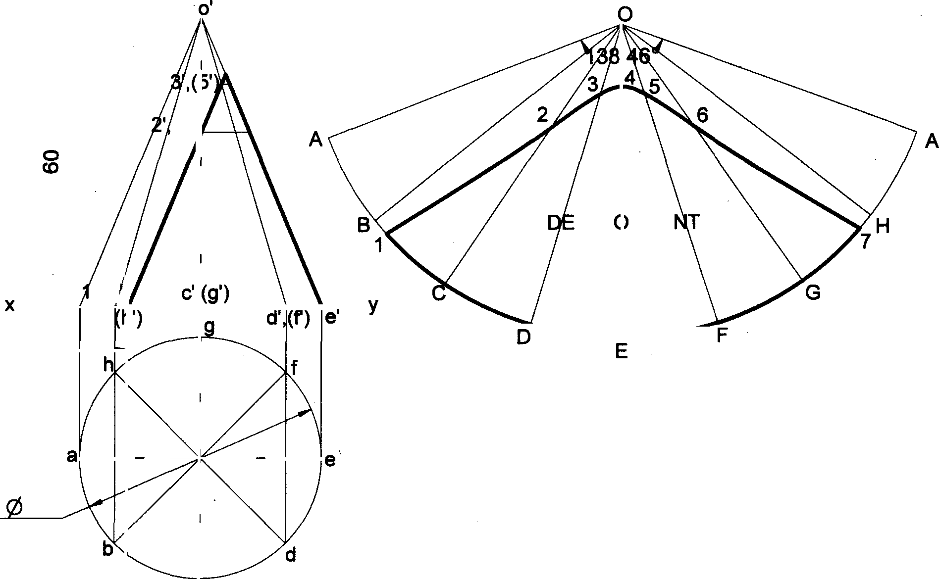

4'

(6'

VEL PME

VP ’,(7

HP a’ b',

10

50



147

Problem 47 Draw the development of the lateral surface of a funnel consisting of a cylinder and a frustum of a cone. The diameter of the cylinder is 20mm and top face diameter of the funnel is 80mm. The height of frustum and cylinder are equal to 60mm and 40mm respectively.

#### Solution

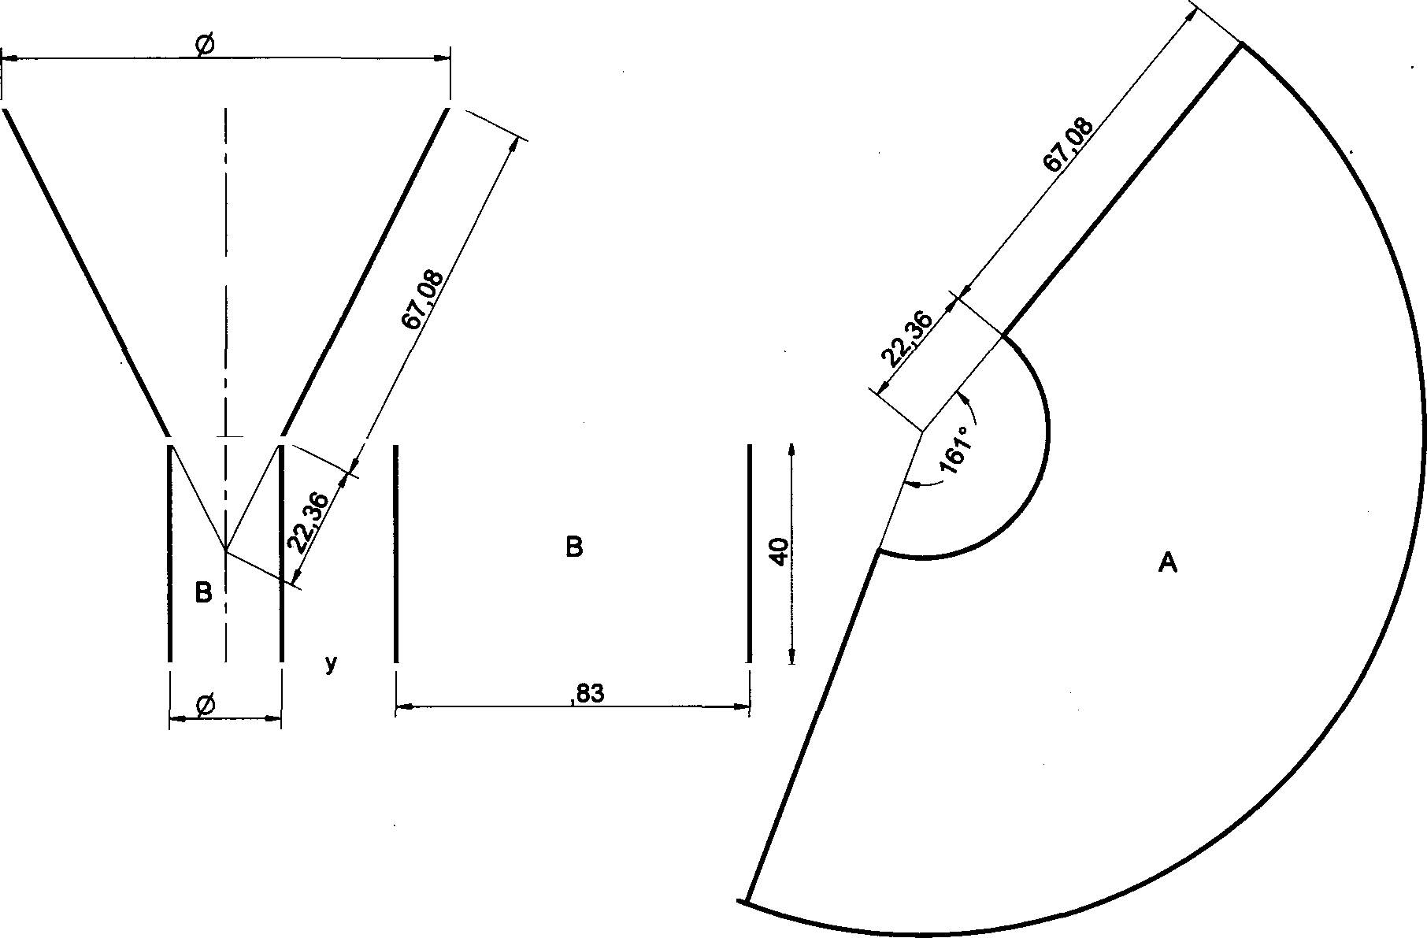

80

A

DEVELOPMENT

DEVELOPMENT

VP HP

20

62

y

40

Problem 48 Draw the development of the lateral surface of the cut cone, whose front view is shown in the following figure.

#### Solution

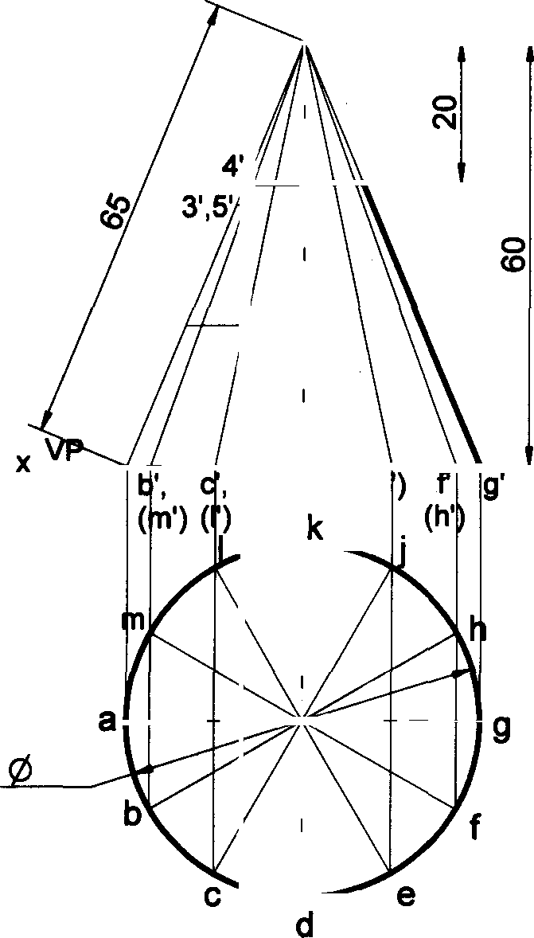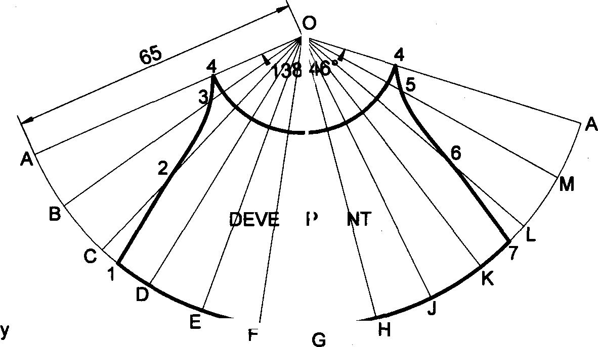

LO ME

2',6

1',7

HP a’ k') e'§

50

d

148

Problem 49 A funnel is to be made of sheet metal. The funnel tapers from 40 mm to 20 mm diameter to a height of 20 mm and from 20 mm to 15 mm diameter, for the next 20 mm height. The bottom of the funnel is beveled off to a plane inclined at 450 to the axis. Draw the development of the funnel.

Solution

Problem 50 A funnel is made of sheet metal. The funnel tapers from 60 mm. to 30 mm. diameters to a height of 25 mm. and then forms to a cylinder with a height of 50 mm. Bottom of funnel is beveled off completely at an angle of 450 to axis Draw the development of funnel.

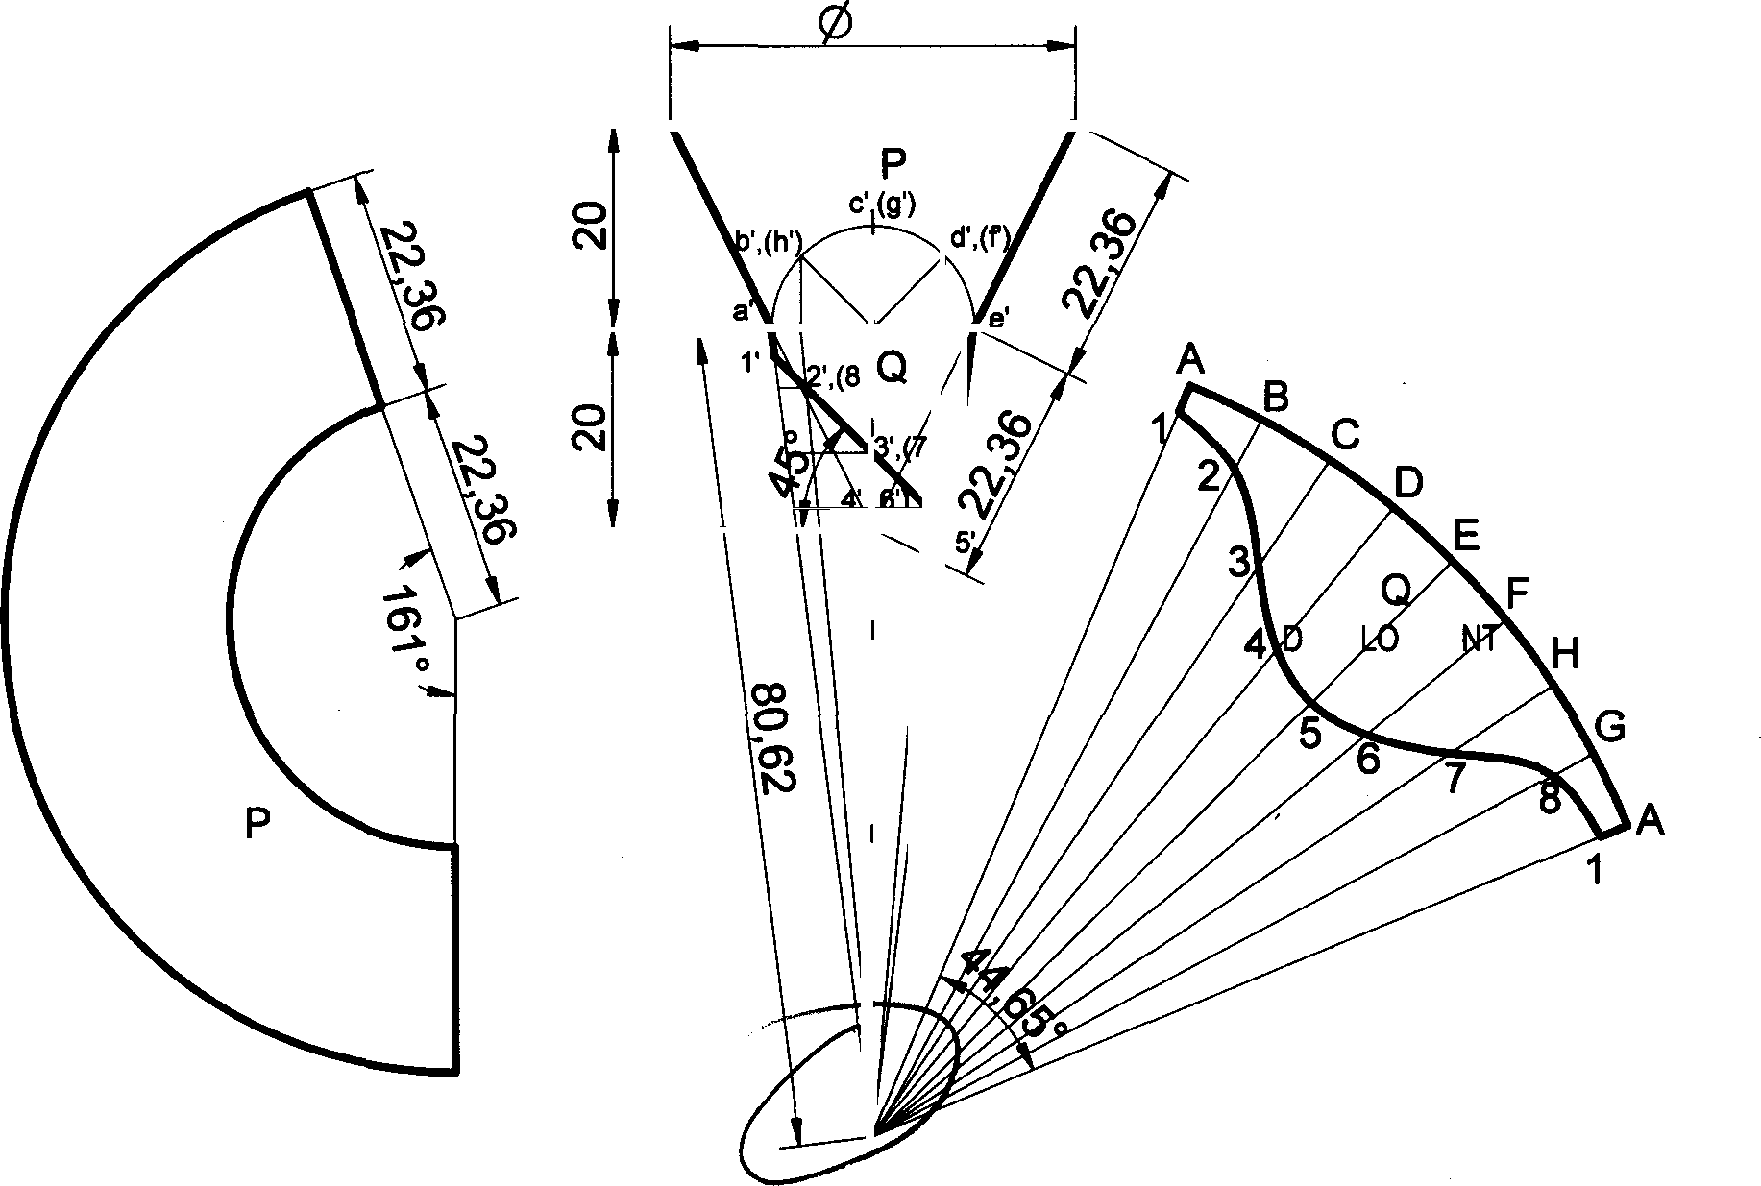

40

EVE PME

DEVELOPMENT

Solution

A

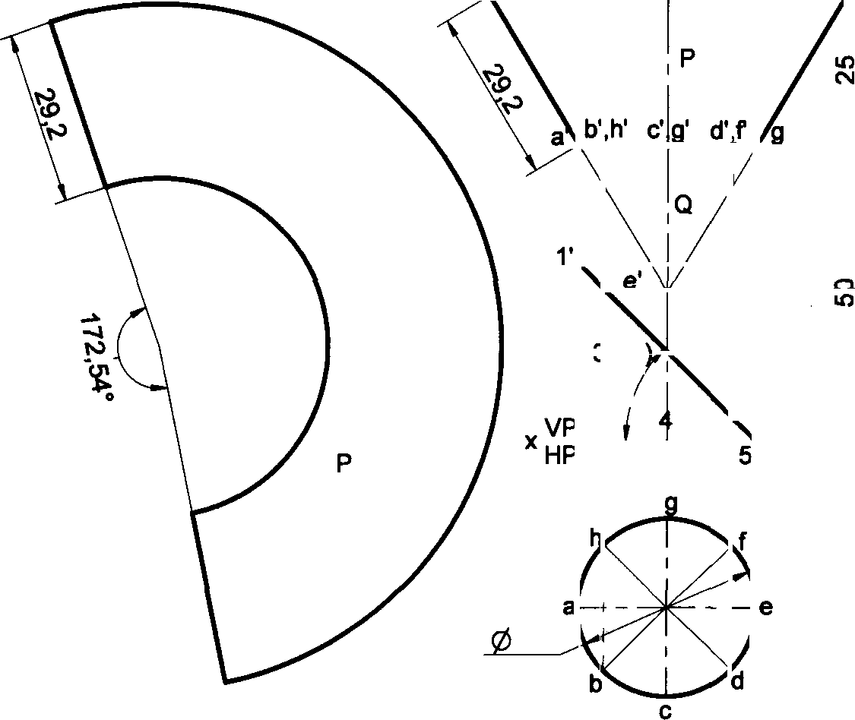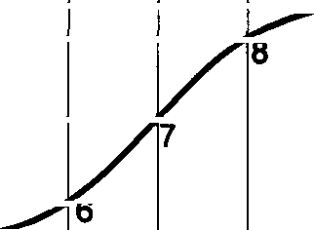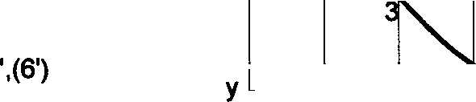

@ 60

94 25

B C D E F G H

DE ELO MEN

2'(

5

DEVELOPMENT

30

)

1

149